
INDUSTRY REPORT
Global Automobile & Light-Duty Motor Vehicle Manufacturing
Feb 2026

About

IBISWorld
IBISWorld specializes in industry research with coverage on thousands of global industries. Our comprehensive data and in-depth analysis help businesses of all types gain quick and actionable insights on industries around the world. Busy professionals can spend less time researching and preparing for meetings, and more time focused on making strategic business decisions.

Table Of Contents | Standard

1. About 4
Codes 4
Definition 4
Related Terms 4
What's Included 4
Companies 4
Related Industries 5
Additional Resources 5
2. At a Glance 6
Key Takeaways 6
Products and Services 7
Major Players 8
Key External Drivers 9
Industry Structure 9
SWOT 10
Executive Summary 10
3. Performance 12
Highlights 12
Key Takeaways 12
Performance Snapshot 13
Outlook 24
Life Cycle 28
4. Products and Markets 29
Key Takeaways 29
Products and Services 30
Major Markets 35
International Trade 37
Imports 40
Exports 41
5. Geographic Breakdown 43
Key Takeaways 43
Business Locations 44
6. Competitive Forces 48
Key Takeaways 48
Concentration 48
Barriers to Entry 50
Substitutes 51
Buyer & Supplier Power 53
7. Companies 55
Key Takeaways 55
Market Share 56
Companies 57
8. External Environment 69
Key Takeaways 69
External Drivers 69
Regulation & Policy 72
Assistance 74
9. Financial Benchmarks 76
Key Takeaways 76
Cost Structure 76
Key Ratios 80
10. Key Statistics 82
Industry Data 82

1. About
https://my.ibisworld.com/gl/en/industry/C2531-GL/about

Codes
ISIC Rev. 4 | 2910

Definition
Operators in the Global Car and Automobile Manufacturing industry manufacture chassis for automobiles and light-duty motor vehicles, and assemble final automobiles and light-duty motor vehicles. These vehicles include passenger cars, pickup trucks, sport utility vehicles, crossover utility vehicles and vans.

Related Terms

HYBRID VEHICLES
Cars that run on a combination of an electric battery and a gasoline engine to achieve higher fuel efficiency than a standard car.

BIG THREE
A term referring to General Motors, Ford and Chrysler, which are the three largest US automakers.

FLEXIBLE-FUEL VEHICLES
Vehicles that run on two different types of fuel, most commonly ethanol and gasoline.

What's Included
- Manufacturing passenger cars
- Manufacturing light trucks and sport utility vehicles
- Manufacturing vans

Companies
- Toyota Motor Corporation
- Volkswagen AG
- Ford Motor Company
- General Motors Company
- Stellantis NV
- Hyundai Motor Company
- Mercedes-Benz Group AG
- BYD Company Limited
- Honda Motor Company Ltd.
- Kia Corporation
- Nissan Motor Co. Ltd.
- Tesla, Inc.
- SAIC Motor Corporation Limited
- Tata Motors

Related Industries

Industries in the Same Sector
- Competitors:
  - Global Heavy-Duty Truck Manufacturing
  - Global Ship & Boat Building
- Complementors:
  - Global Tire Manufacturing
  - Global Automobile Engine & Parts Manufacturing
  - Global Auto Parts & Accessories Manufacturing

International Industries
- Automobile & Light-Duty Motor Vehicle Manufacturing in the US
- Motor Vehicle Manufacturing in Australia
- Motor Vehicle and Parts Manufacturing in New Zealand
- Motor Vehicle Manufacturing in the UK
- Motor Vehicle Manufacturing in Germany
- Electric Vehicle Manufacturing in Germany
- Automobile Manufacturing in China
- Automobiles & Pickup Trucks Manufacturing in Mexico
- Motor Vehicle Manufacturing in Spain
- Motor Vehicle Manufacturing in France
- Motor Vehicle Manufacturing in Italy

Additional Resources
- International Organization of Motor Vehicle Manufacturers
- European Automobile Manufacturers Association
- Auto Alliance
- WardsAuto
- US Census Bureau

2. At a Glance
https://my.ibisworld.com/gl/en/industry/C2531-GL/at-a-glance
Revenue  $2.6tr  ’21-’26 ↓ 0.8 %  ’26-’31 ↑ 1.9 % | Employees  2m  ’21-’26 ↓ 3.6 %  ’26-’31 ↑ 0.9 % | Businesses  793  ’21-’26 ↑ 0.2 %  ’26-’31 ↑ 0.5 %
Profit  $199.1bn  ’21-’26 ↑ 3.7 % | Profit Margin  7.6%  ’21-’26 ↑ 1.5 pp | Wages  $96.9bn  ’21-’26 ↓ 2.4 %  ’26-’31 ↑ 1.1 %

Key Takeaways

Performance
- Manufacturers that successfully innovate will dominate the automotive landscape. Companies are scrambling to create electric and autonomous vehicles to differentiate from competitors.
- Many automakers are prioritizing emerging economies. Countries like China and India have growing middle-class populations, leading to more vehicle purchases.
- Manufacturers must address consumer concerns regarding hybrid, plug-in hybrid and electric vehicles. Manufacturers that create longer-driving and more affordable cars will gain a clear market advantage in the burgeoning hybrid and EV market.
- The end of EV rebates in the US and Canada poses major challenges to EV development. Pushback on EV timelines in the US and EU suggests EVs have placed significant cost pressures on automakers.

Products and Markets
- Automakers respond to changing consumer preferences, tweaking product lines each year. SUVs, crossovers and electric vehicles have become especially popular in many markets.
- Some products are restricted to specific demographics. Pickup trucks and SUVs are less popular in Europe but are a mainstay in North American markets.
- US tariff policies will ripple through global supply chains. The US will likely consume cars with higher US content, like Tesla, while other companies relocate supply chains to less impacted regions, like Southeast Asia.
- US automakers will face tariff retaliation. China, Canada and other nations have floated or implemented duties on the US auto sector. These policies will potentially lead to a minor reduction in trade volumes and higher prices, though the necessity of cars will likely limit the overall impact.

Products and Services
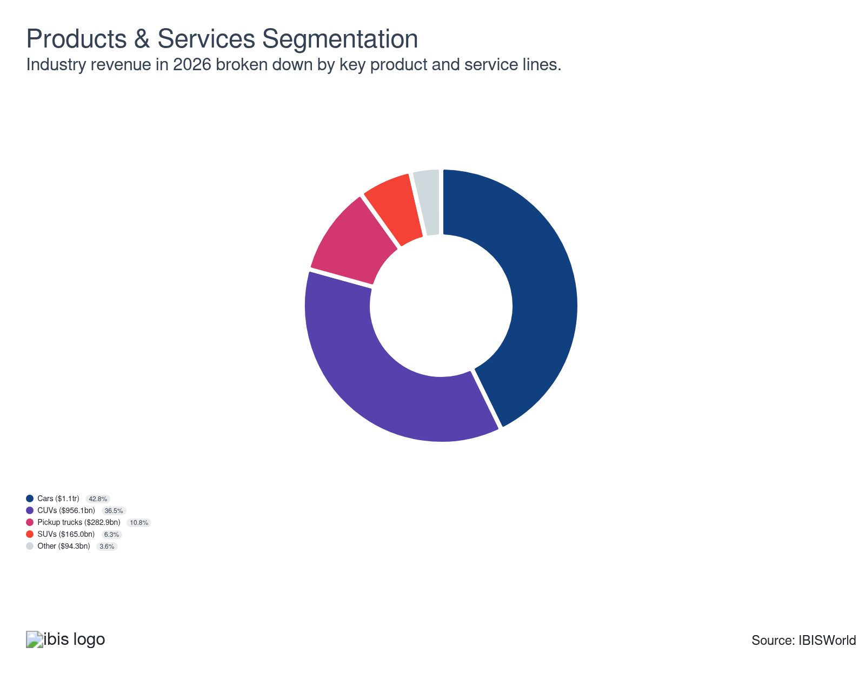

Major Players
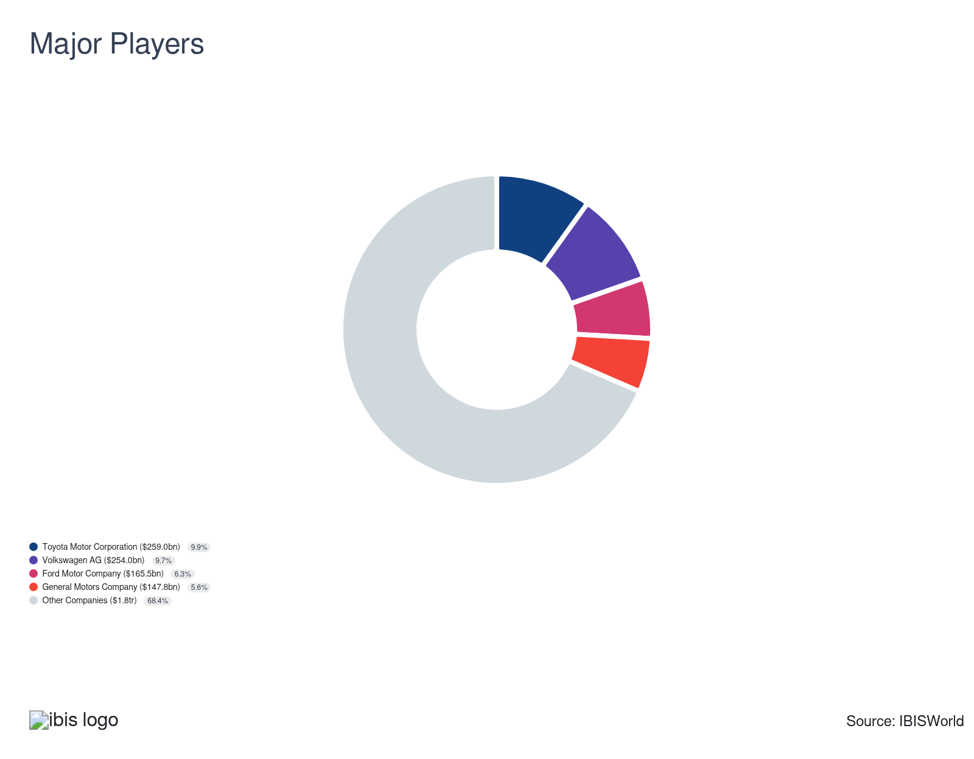

Key External Drivers
Key External Drivers | Impact
Global per capita income | Positive
GDP of the BRIC nations | Positive
World price of crude oil | Negative
World price of steel | Positive

Industry Structure
Characteristic | Level | Trend
Concentration | Low
Barriers To Entry | Very High | Steady
Regulation and Policy | Very High | Increasing
Life Cycle | Mature
Revenue Volatility | Moderate
Assistance | High | Increasing
Competition | Very High | Increasing
Innovation | Very High

SWOT
Strengths  Low Product/Service Concentration  High Revenue per Employee | Weaknesses  Low Profit vs. Sector Average  High Customer Class Concentration  High Capital Requirements | Opportunities  High Revenue Growth (2020-2025)  High Revenue Growth (2025-2030)  High Performance Drivers  Global per capita income | Threats  Low Outlier Growth  World price of crude oil

Executive Summary

Car crash: The industry suffered due to slowed demand for passenger vehicles as a result of the pandemic
Global car and automobile manufacturers have faced numerous challenges over the past decade, given major exogenous shocks, shifting consumer preferences and supply chain disruptions. In particular, significant technological improvements, particularly regarding hybrid and electric vehicles, internal combustion engine fuel efficiency, infotainment development and autonomous driving capabilities, coupled with rising per capita disposable income, have spurred global demand from the growing global middle class. Additionally, strong economic recoveries in most developed and emerging nations following the pandemic have spurred climbing motorization rates and vehicle registrations. However, companies have struggled with lower demand in OECD nations through 2025. Higher prices from tariffs, economic uncertainty and the end of EV rebates in North American countries have discouraged purchases across the board, especially with luxury and electric vehicles. Overall, revenue has faltered at an expected CAGR of 0.8% to $2.6 trillion through the current period, despite a 1.5% jump in 2026. Profit will climb to 7.6% through 2026, largely as companies adapt to tariffs and other recent supply and demand disruptions.
Aluminum and steel are significant inputs for most automakers. Most input manufacturers cut production amid the pandemic, leaving automakers with supply chain shortages and long lead times, especially as automotive demand rebounded following the pandemic. Semiconductors and other integral electronic component manufacturers also failed to meet automaker's demand, exacerbating supply chain issues. Despite these issues, manufacturers have successfully pushed costs onto consumers, expanding profit. Even so, flourishing demand has enabled most automakers to begin recoveries. Many companies have also expressed greater supply chain oversight following disruptions, leading to more nearshoring, vertical integration and strategic partnerships and alliances. Even so, labor strikes, union demands and lingering economic uncertainty have contributed to volatility.
Revenue for automakers will swell at an expected CAGR of 1.9% to $2.8 trillion through the outlook period as the industry rides climbing global per capita income and continued growth in developing economies. Global manufacturers will continue to invest heavily in technology and innovation, making waves with new electric and autonomous driving technologies. Companies will also lean on government support regarding electric and hybrid vehicle technology. However, the rollback of several EV programs and guidelines may encourage companies to push more into hybrids and efficient engines, shifting the industry's balance and makeup. Even so, companies remain committed to EV development, having already invested billions into these programs. Tariff policies may also restrict many aspects of trade, preventing automakers from purchasing certain foreign inputs or from seamlessly accessing certain export markets.

3. Performance
https://my.ibisworld.com/gl/en/industry/C2531-GL/performance

Highlights
Revenue  $2.6tr  2021-26 CAGR ↓ 0.8 %  2026-31 CAGR ↑ 1.9 % | Employees  2m  2021-26 CAGR ↓ 3.6 %  2026-31 CAGR ↑ 0.9 % | Businesses  793  2021-26 CAGR ↑ 0.2 %  2026-31 CAGR ↑ 0.5 %
Profit  $199.1bn  2021-26 CAGR ↑ 3.7 % | Profit Margin  7.6%  2021-26 CAGR ↑ 1.5 pp

Key Takeaways
- Manufacturers that successfully innovate will dominate the automotive landscape. Companies are scrambling to create electric and autonomous vehicles to differentiate from competitors.
- Many automakers are prioritizing emerging economies. Countries like China and India have growing middle-class populations, leading to more vehicle purchases.
- Manufacturers must address consumer concerns regarding hybrid, plug-in hybrid and electric vehicles. Manufacturers that create longer-driving and more affordable cars will gain a clear market advantage in the burgeoning hybrid and EV market.
- The end of EV rebates in the US and Canada poses major challenges to EV development. Pushback on EV timelines in the US and EU suggests EVs have placed significant cost pressures on automakers.

Performance Snapshot
Revenue: | ↓ 2021-26 Revenue CAGR -0.8%
Revenue  $2.6tr  ’21-’26 ↓ 0.8 %  ’26-’31 ↑ 1.9 % | 2026 Revenue Growth  ↑ 1.5 % | Revenue Volatility  Moderate
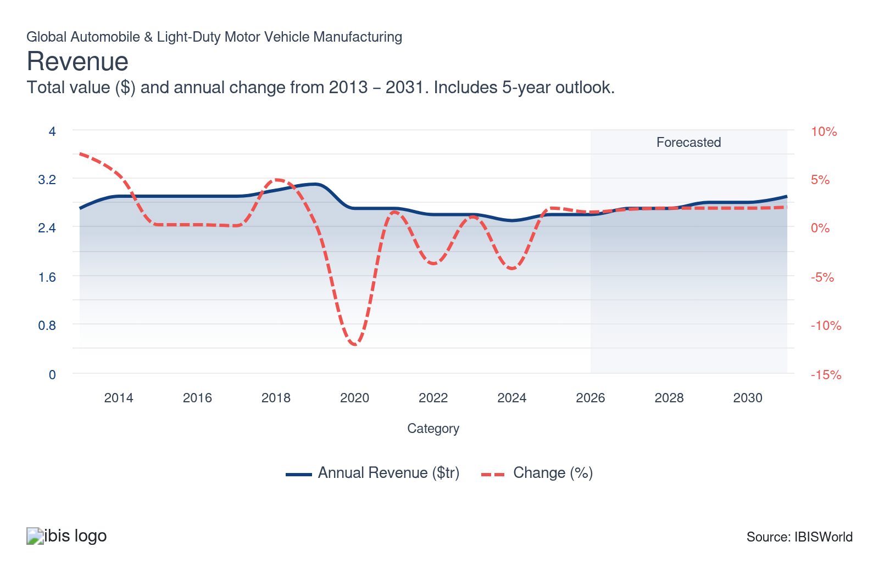
Employees: | ↓ 2021-26 Employees CAGR -3.6%
Employees  2m  ’21-’26 ↓ 3.6 %  ’26-’31 ↑ 0.9 % | Employees per Business  2,423  ’21-’26 ↓ 3.7 %  ’26-’31 ↑ 0.4 % | Revenue per Employee  $1m  ’21-’26 ↑ 2.9 %  ’26-’31 ↑ 1.0 %
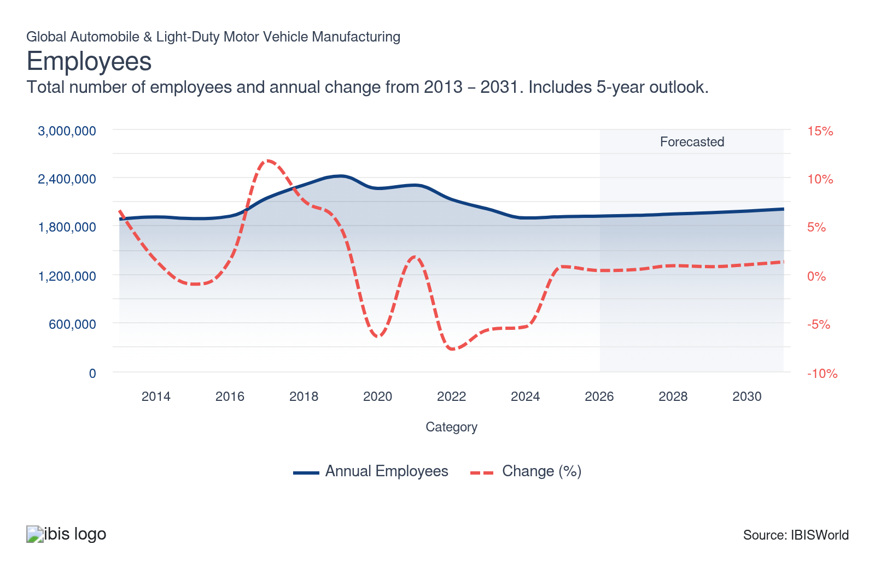
Businesses: | ↑ 2021-26 Business CAGR +0.2%
Businesses  793  ’21-’26 ↑ 0.2 %  ’26-’31 ↑ 0.5 % | Employees per Business  2,423  ’21-’26 ↓ 3.7 %  ’26-’31 ↑ 0.4 % | Revenue per Business  $3.3bn  ’21-’26 ↓ 1.0 %  ’26-’31 ↑ 1.5 %
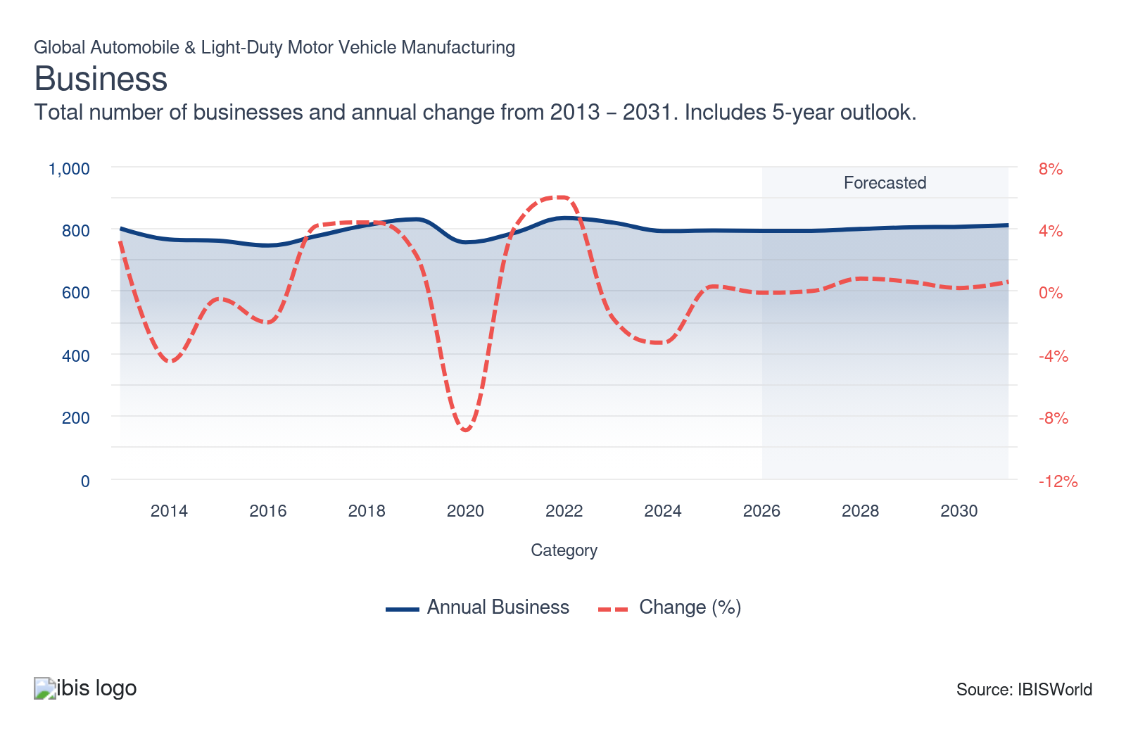
Profit: | ↑ 2021-26 Profit CAGR +3.7%
Total Profit  $199.1bn  ’21-’26 ↑ 3.7 % | Profit Margin  7.6%  ’21-’26 ↑ 1.5 pp | Profit per Business  $251.0m
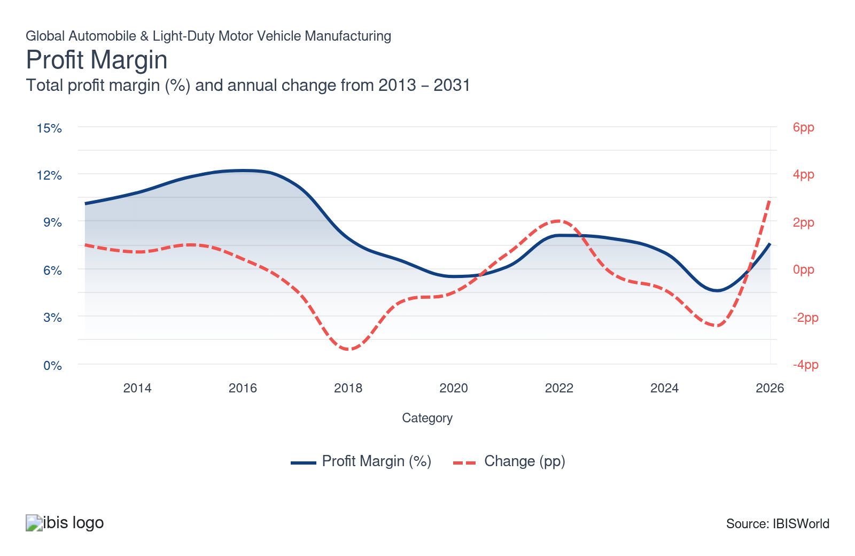
Current Performance
Current Performance

What's driving current industry performance?

Automakers have combatted volatile supply chains
- Automobile manufacturers have endured severe supply chain disruptions following the pandemic, the Russian invasion of Ukraine and other regional conflicts. For instance, piracy and conflict in the Middle East have hindered Red Sea shipping lanes, which account for more than 30.0% of global container trade and 10.0% of all global trade, according to the United Nations. Rerouting key raw materials, like oil, plastic and steel, around the Cape of Good Hope can increase transit times by 30.0%, according to JP Morgan, leading to significant delays for forged metals and other inputs for automakers while reducing profitability.
- Semiconductor shortages have also slammed automakers. Most auto electronics suppliers and vertically integrated automakers rely on legacy or mature semiconductors and process nodes; these chips support older systems, like brakes, airbag controls and power windows. These shortages forced companies to slash production as they waited for key components, leading to longer lead times. In many countries, automobile demand far outpaced supply, leading to skyrocketing new-car prices. On the other hand, volatile oil prices have pushed some consumers toward more efficient models, like EVs and hybrids.
- Leading manufacturers, especially luxury or premium names, were more successful at pushing costs onto buyers, leveraging strong reputations, brand recognition and consumer loyalty. However, overall profit declined for the industry, often from lower-priced automakers absorbing costs to maintain market advantages. As a result, many companies have prioritized supply chain localization and greater supply chain oversight, creating partnerships with major semiconductor and technology companies like NVIDIA, Foxconn and LG.
- For instance, Mercedes-Benz, JLR, Hyundai, BYD, NIO, XPENG and Volvo are among NVIDIA’s featured partners in the company’s DRIVE Partner Ecosystem. The company also has agreements with many other non-featured automakers, like Lucid, Rivian and Kia. In comparison, Stellantis, Nissan and others have partnerships with Foxconn. Similarly, Ford and General Motors both have partnerships with Global Foundries. Almost all manufacturers partner with or buy from one of these semiconductor manufacturers and technology providers.
- Companies have also taken an ESG approach to supply chain management, especially following the United States’ growing list of banned industrial, automotive and electronics suppliers in the Xinjiang region. Global automakers must be aware of these lists when selling new cars in the US, Canada and some other regions. Lear, a key supplier, has faced US Senate inquiries alongside some of its major clients, namely BMW, Jaguar-Land Rover and Volkswagen.
- The United Auto Workers Union in the US has also called for US automakers to cut ties with these suppliers. In general, these disruptions and events have led automakers to take a more involved, direct approach, pushing them to form closer, more collaborative relationships across the automotive supply chain and with semiconductor manufacturers.

Automakers have faced pressure from regional unions
- Unions have a major role in global automotive supply chains. Most automotive powerhouses are subject to unions with varying degrees of strength and negotiating power. Major unions include the United Auto Workers (UAW) in the United States, Unifor in Canada, IG Metall in Europe, the Confederation of Japan Automobile Workers' Unions (JAW), Hyundai Motor Union under the Korean Metal Workers' Union (KMWU) and the All-China Federation of Trade Unions (ACFTU).
- The UAW, IG Metall and the KMWU often have the most bargaining power while Canada’s weakened and exposed auto sector has somewhat constrained. In comparison, the JAW rarely strikes; the union targeted its first pay hike target in the past seven years in December 2024, according to Reuters. In China, the ACFTU is the only state-approved union, suggesting limited negotiating ability. In fact, many Chinese auto workers have seen benefits and salaries cut following price wars with Tesla and other foreign manufacturers, according to Reuters and Coalition to End Forced Labour in the Uyghur Region.
- In the United States, the ratification of new labor contracts in 2023 and 2024 particularly impacted the Big 3 automakers and other companies with significant presence in the US. Strikes contributed to more than 869,200 cumulative factory days idle, reportedly costing companies more than $80.0 million a day. Big 3 automakers subsequently laid off more than 5000 workers, with more layoffs expected through the outlook period as union demands take effect.
- Ford has also indicated in earnings calls that labor demands will make manufacturing each new vehicle cost than $800.00. Similarly, GM has reported that new labor contracts will increase costs by an average of $575 per vehicle. Automakers will pass much of these costs onto consumers, compounding upon car prices that skyrocketed more than 30.0% during the pandemic.
- To combat union pressures, some automakers have implemented flexible workforce strategies that balance labor costs and job security. Automakers might explore avenues such as offering voluntary early retirement packages, upskilling programs, or temporary workforce adjustments during production fluctuations. On the other hand, companies may increasingly target regions with weaker union presences and right-to-work laws. For example, many Japanese, German and Korean automakers have facilities in the Southeast and Southwest United States, rather than the Great Lakes and West regions.
- The strength of these various unions has also limited automation, preventing automakers from catching up to rivals in China or Japan. In general, unions seek alternatives to automation, considering it a major threat to factory employment rates, diminishing worker leverage in negotiations. According to the International Federation of Robotics (IFR), China and Japan have eclipsed the United States, Germany and South Korea in auto industry automation and general robotics adoption. Companies must prioritize union relationships to prevent lockouts, strikes and other profit-eroding activity.

Companies emerge in developing markets
- Established automakers have continued to invest production capabilities in their most lucrative markets or close to them, limiting trade activity. However, emerging markets represent some of the largest opportunities for car manufacturers; burgeoning middle classes and rising economies across developing nations, especially the BRICS+ and ASEAN member nations, have led to increased car ownership and rapidly rising vehicle expenditure.
- In fact, China, India, Vietnam, Romania and Ecuador have displayed the fastest motorization rates, greater than 7.0%, according to the OICA, signaling massive growth opportunities across many developing economies. In comparison, most of the EU, the US, Canada, Japan and Korea display motorization rates between -1.0% and -3.0%.
- Manufacturers in India and China, namely Tata Motors, SAIC Motor and BYD, have become popular, though Russian and Brazilian automakers have displayed smaller contributions. However, many companies have pulled out of Russia following the invasion of Ukraine, slashing the region’s growth opportunities and shifting investments toward Czechia, Poland and other Eastern European nations.
- Chinese consumers have increasingly adopted cars as the primary means of transport as the middle class grows. As a result, Chinese automakers have started dominate their domestic market, manufacturing automobiles at a much lower price point. The country also has a burgeoning electric vehicle market; BYD and Nio, for example, outcompete Tesla, Volkswagen, Toyota and other Western EV brands. European brands had previously dominated Chinese markets, maintaining partnerships with local companies. For instance, BMW reports that the Chinese market historically made up more than 30.0% of revenue; pushback from leading Chinese brands represents a clear threat to many established automakers’ revenue outlooks.
- Even so, safety concerns, stigmas and overwhelming tariffs placed on these cars in many Western countries have severely limited the expansion of Chinese-made automobiles globally. Even so, many global brands have partnered with domestic manufacturers to access this growing market, often creating joint ventures. Notably, SAIC and Volkswagen have partnered to make VW vehicles accessible to the Chinese market and compliant with Chinese regulators.
- Similarly, India is well-positioned for growth as regional income levels rise. The country's top manufacturer, Tata Motors, represents a growing portion of the market with well-established luxury brands Land Rover and Jaguar, alongside its proprietary passenger vehicle segment. In general, companies have opened new facilities in these emerging economies to take advantage of surging demand. Strong marketing campaigns can help develop brand loyalty in these regions, giving automakers a clear competitive edge akin to a first-mover advantage.

Automakers have pushed for inexpensive EVs amid uneven adoption rates
- Despite major road bumps, EV adoption rates have remained solid, steadily growing through the current period, especially driven by sales in China. According to the International Energy Agency (IEA), electric vehicles (EVs) and plug-in hybrid vehicles (PHEVs) accounted for 38.0% of all sales in China, compared with 21.0% in Europe and 10.0% in the United States. However, the United States accounted for the second-largest number of EVs sold in 2023 at 1.3 million, double that of Germany but 7.0 million less than China.
- China accounted for approximately half of the world’s EV and PHEV stock in 2023 (latest data available). However, research suggests that consumers in developed nations, especially the United States, are purchasing EVs as a second or third option, specifically for shorter, local trips, undermining government sales mandates and policies. Consumers aren’t seeing EVs as a replacement but as a supplement; high prices, especially, contribute to this trend.
- Consumers remain wary regarding battery capacity, vehicle performance, charging availability and charging speed despite EV manufacturers introducing new advancements to address many of these challenges. For example, companies have used lighter materials, like aluminum, carbon fiber and thermoplastic, to compensate for heavier electric batteries and drivetrains.
- Many American automakers have also struggled to generate positive returns on current EV models, with General Motors and Ford reporting billion-dollar losses in EV programs. In fact, Ford is on pace to lose more than $5.0 billion through 2024 on EV models. Each vehicle is expected to lose $44,000 dollars. However, GM has reported strong EV results in 2024 and early 2025 (before the end of EV rebates), with the Cadillac brand reporting its highest sales volumes since 2016, due to strong performance from the LRYRIQ. Ford and Stellantis have especially struggled, with Ford reporting another multi-billion-dollar EV loss in 2025.
- Companies must work to create EVs that are less expensive to produce, enabling companies to cut prices and appeal to more consumers. Chinese producers, like BYD, NIO, Geely and Aion, have made strides to creating affordable, long-distance EVs, but prohibitive tariffs have made Chinese carmakers uncompetitive in US and EU markets. More specifically, Tesla and BYD have largely competed for the top EV spot globally; Tesla’s Model Y and 3 had 1.2 million and 529 thousand deliveries in 2023, respectively, while BYD's top three models had 543 thousand, 419 thousand and 355 thousand deliveries, respectively. SAIC-GM-Wuling and GAC Aion, Chinese subsidiaries, also cracked the top ten in terms of vehicle deliveries.
- Stellantis has already found success in this market in Europe with the Citroen e-C3; however, major struggles in the US have caused the company to scrap some EVs in the Jeep, Dodge and Ram brands, instead pivoting back to combustion engines, particularly the iconic V8 model. Conversely, Tesla has largely abandoned plans for a $25,000 EV, given market conditions and higher car prices overall. Even so, the $25,000 EV remains a major focal point for the industry, with most automakers working to reduce EV costs. Other companies will also lean toward hybrid technology as a more profitable intermediate step for EVs; many Asian and European producers, such as Honda, Toyota, Hyundai and Volvo have reported robust hybrid sales, generating strong returns and leaving these companies well positioned to invest in EV technology in the near future.

The end of North American rebates may cause significant swings in regional EV investment
- Rebates and other government support programs have played a key role in EV development and adoption. A removal or decrease in aid can cause significant volatility in this burgeoning market, causing consumers and automakers alike to shy away from respective higher costs. Many countries have rolled back EV and PHEV rebates as sales increase and costs pile up. For instance, Germany, Ireland, Sweden, France and Korea have all reduced available EV rebates.
- The end of EV rebates in Canada and the United States has also had a significant impact, especially considering the overall spending power and vehicle consumption in North America. Companies may need to adjust production schedules and pricing strategies to remain competitive in countries with diminishing EV benefits, tying back into the $25,000 EV goals. Consumers may start to gravitate back toward ICEs and hybrid vehicles if costs start to climb, especially in regions without ample charging infrastructure.
- Canada and the US have expressed some significant demand shifts through 2025 and early 2026. More specifically, S&P Global Mobility and NADA reported that Canadian ZEV sales fell from 19.0% to 9.7% through 2025, while US EV sales fell from 8.4% to 7.7% at the end of 2025. Automakers expect limited EV sales through 2026. Comparatively, hybrid sales have spiked in both regions.
- As a result, several companies have further pulled back from EV investment in the United States and Canada, especially after weak Q4 2025 sales. Most notably, Ford cancelled its F-150 Lightning, scrapped a second-generation EV pickup and commercial van program. Stellantis reversed several US-focused EV initiatives, including halting the Ram EV pickup, modifying the Dodge Charger to reintroduce gasoline powertrains and shifting billions toward new gasoline models while limiting its US EV lineup. Finally, GM has scaled back several joint ventures and battery plants, anticipating weak EV volumes.
- Honda announced it would significantly cut EV investment, shifting funds to hybrids. Toyota will also push back the start of US EV production at its Kentucky plant from late 2025 to around mid-2026 and proceed more cautiously with volume targets. In comparison, Hyundai-Kia is recalibrating its strategy by adding US-built hybrids at the Georgia Metaplant, using hybrids as a bridge during an EV demand plateau and limiting pure-EV exposure growth while maintaining overall local production expansion.
- In general, companies are focusing on hybrid innovation in the United States, while leaning into continued EV investment in regions with greater support. These companies must work to develop more cost-effective EVs, allowing successful introduction into broader consumer markets, especially lower-income buyers. Companies must also assist in charging infrastructure, making these vehicles more accessible.

Nearshoring and reshoring trends continue to emerge
- Nearshoring has become a critical strategy for automakers, helping companies shorten supply chains, cut transportation time and cost, improve communication and reduce disruption risks while still benefiting from cost advantages versus fully domestic production. Certain areas have become indispensable for automakers, serving as major hubs for North American, European or Asian markets.
- Specifically, Mexico and Latin America, Eastern and Central Europe and Southeast Asia have emerged as key production hubs. Mexico has become one of the largest automotive exporters, ranking fifth globally and leapfrogging the United States. Similarly, JATO reports that Czechia, Romania, Turkiye and Slovakia were among the largest production hubs of European markets. Factories in these countries accounted for nearly 24.0% of all European passenger vehicle registrations, representing a notable increase from the previous decade.
- This strategy reaps significant benefits. For one, proximity allows faster replenishment and model changes, supporting just-in-time systems and reducing stockouts or discounting. The move also enables companies to take advantage of regional trade agreements, such as the USMCA, the Asia-Pacific Trade Agreement (APTA) and various EU trade deals.
- This activity will continue, particularly as tariffs continue to pressure bottom lines. This strategy also reinforces supply chain flexibility, hastening responses to supply chain disruptions, regional policy changes and demand shifts. Companies can leverage reshoring to ensure more stable profit growth through the outlook period.

What influences industry volatility?

Supply chain disurptions create volatility
- Automakers faced severe supply chain disruptions following the pandemic, the Russian invasion of Ukraine and disruptions in the Red Sea. In particular, surging crude oil prices have unsettled metal, electronics, rubber and adhesive supply chains, saddling automakers with additional costs.
- Semiconductor shortages also slammed automakers, preventing manufacturers from sourcing key components for advanced vehicles, leading to longer lead times, major car shortages and skyrocketing new car prices. Companies struggled to meet demand, causing car prices to surge.
- Semiconductor and electronic component shortages have forced automakers to reevaluate supply chains and create closer relationships with key suppliers. Some companies have also increased in-house production capacity of various auto parts, reducing reliance on external supply chains.
- Tariff policies have introduced another wave of uncertainty across supply chains, encouraging some nearshoring and reshoring trends in North America. Many companies have opened new facilities in the United States, envisioning higher costs. Broader global restrictions on Chinese products and Russian steel have also influenced procurement strategies, especially in Europe and Asia.

Economic uncertainty injected volatility into the industry
- The pandemic and inflationary pressures have massively influenced demand for new vehicles, creating volatility for automobile and light duty motor vehicle manufacturers. In particular, the lockdown restrictions limited driving activity, cutting demand for new vehicles at the start of the period.
- Similarly, climbing interest rates in many countries have influenced consumer purchasing habits through most of the current period. High interest rates made auto loans significantly more expensive, especially for lower-income buyers, while fluctuating consumer confidence and spending discouraged big-ticket purchases for most buyers.
- Normalizing conditions have largely supported growth in the current year. For instance, falling interest rates have made auto loans more palatable, encouraging spending on more expensive vehicle models. Stronger economy conditions will reduce volatility through most of the outlook period. The industry and the broader sector both display relatively low, predictable revenue volatility.

Automakers benefited from pent-up travel demand following the pandemic
- As pandemic restrictions eased, many individuals have jumped at the chance to travel again, purchasing new vehicles for single-day and overnight trips. In the United States alone, 81.0% of travelers planned a road trip in 2022 (latest data available)
- As a result, rental car businesses have updated their fleets to accommodate more vacationers, creating new opportunities for automakers. This market growth has created strong growth despite the mounting threat posed by economic uncertainty, lingering inflation and potential tariff threats.
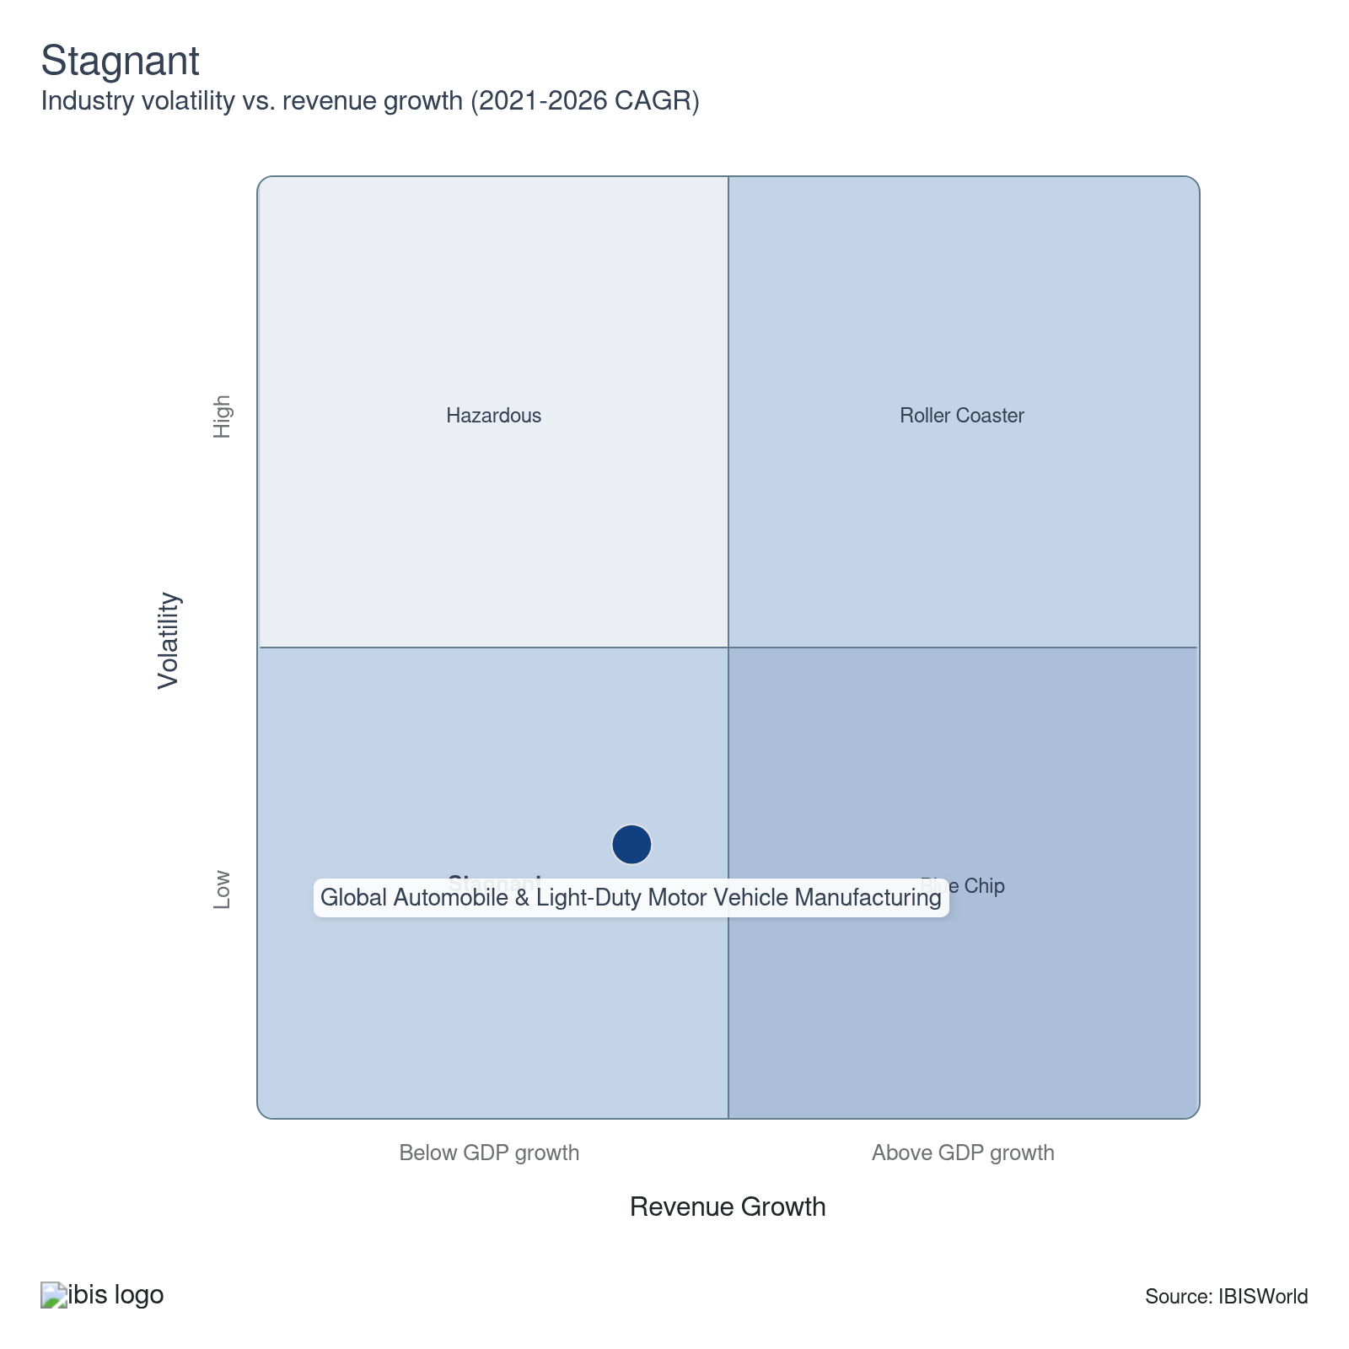

How do successful businesses overcome volatility?
Securing export markets
Developing export markets helps automakers negate any downturns in domestic markets.
Secure the latest available and most efficient technology and techniques
Automakers must be prepared to automate and integrate new technologies to streamline production, design and development costs to maximize returns and remain competitive.
Outlook | ↑ 2026-31 Revenue CAGR +1.9%

What's driving the industry outlook?

Tariff policies will have a major influence on global automakers
- Tariffs play a major role in shaping the competitiveness of various automobile manufacturers. While President Trump’s proposed tariffs will have a major impact on the industry moving forward, existing tariffs on Chinese EVs from the US and the European Union will also have a massive impact on the industry. These tariffs hope to combat unfair subsidies from the Chinese government, enabling Chinese EV producers to sell below market value and undermine prices in the EU and US.
- However, major European automakers have vehemently opposed said tariffs, with Volkswagen denouncing the EU’s actions. VW, BMW and other European companies fear Chinese retaliatory tariffs and policies will erode these manufacturers’ already dwindling market shares in the otherwise blossoming Chinese market. For example, these manufacturers may lose access to lower tax rates, grants, easier access to capital, reduced land costs, and competitive lithium battery prices in China. If the Chinese government lifts these benefits, EU manufacturers may need to change their business models, prioritizing nearby locations, such as Vietnam and the rest of Southeast Asia, as launch points for product lines.
- On the other hand, tariffs proposed by President Trump would cause massive changes to the industry’s supply chains and cost structures. These policies, intended to protect American suppliers and automakers, would have a massive impact on automakers that import a significant portion of inputs from China and other targeted countries. For instance, the US president has highlighted Mexico’s role as a potential backdoor for unethical Chinese import dumping, selling products heavily underpriced and leveraging other noncompetitive practices.
- In general, a wide range of tariffs on China, Mexico and Canada will have major implications on North American and Chinese-American trade. China has already placed retaliatory tariffs on many US-made automobiles, impacting General Motors’ and Tesla’s robust Chinese positions. These tariffs would severely impact North American automakers, raising costs across the board and likely making vehicles more expensive. Companies with a higher content of US parts will have face fewer potential roadblocks. Specifically, Tesla consistently ranks first for percentage of domestic content, with every model containing 80.0% or more domestic parts. Many US-specific Honda and Acura models also rank among the top ten.
- US companies may need to prioritize reshoring efforts, moving a greater percentage of production from China, Mexico and other at-risk regions back to the United States. This strategy, however, may increase production costs and prove unfeasible for some automakers, pushing them to instead move production to Southeast Asia, Eastern Europe and other low-cost regions. Other companies may choose to double down, pushing the costs of tariffs onto consumers and continuing production abroad. Both strategies will likely contribute to higher car prices.
- Through 2025, automakers have made a notable effort to move production to the United States. Toyota’s US production has climbed from 11.4% in 2021 to 14.1% through 2025, while Honda’s US production has climbed from 20.7% in 2021 to 27.4% in 2025. Hyundai and Kia have both announced increased US investment, alongside many European automakers. For instance, Volvo is moving production of its popular hybrid model from overseas to South Carolina.

Government programs will encourage EV production, despite some rollbacks
- The United States, Canada and the European Union have each developed laws regarding vehicle carbon emissions. These laws state that all new passenger vehicles produced after a set date must have zero emissions. The EU and Canada have set 2035 as a benchmark for zero-emission vehicles (ZEVs), while the United States has set a target of 50.0% of new vehicle sales to be ZEVs by 2030. Similarly, China’s Development Plan for the New Energy Vehicle Industry includes specific EV sales targets and massive vouchers, which some other governments have called noncompetitive.
- Similarly, fleet emissions standards have forced companies to improve the average mileage of available passenger vehicles. Alongside innovation, many automakers have cut less efficient models. Notably, Chevrolet and Dodge have discontinued their respective muscle car models in favor of more eco-friendly models. Dodge has plans to reintroduce the Challenger and Charger with EV models, with Chevrolet releasing an electric Camaro SUV as part of its 2025 fleet.
- However, the United States has plans to roll back CAFE standards and its EV mandate, with the new administration stating that ambitious fleet standards would stress capital structures, creating major competitive disadvantages for US automakers and forcing them to cut high-emission models, rather than innovate. Specifically, The Trump Administration has planned to reset CAFE to 34.5 MPG by 2031, claiming that previous CAFE standards would have raised car prices up to $1,000. While these regulations may help stabilize profit in the US, they may make US-reliant companies less competitive in European markets with stronger emissions regulations.
- Regardless, government programs will also extend to EV charging infrastructure. Most countries have already enacted costly spending plans to add accessible, low-cost and fast charging stations across urban, suburban and rural environments. According to the International Energy Agency (IEA), South Korea, the Netherlands and China have the most comprehensive charging infrastructures per 1000 EVs. China has the highest total figure of fast and slow publicly available charging stations.
- Other countries will strive to catch up and improve charging infrastructure to make EVs a sustainable option for consumers. Some automakers, like Tesla, have also developed internal energy generation and storage verticals to support charging systems; the Tesla Supercharger is the most notable example. On the other hand, BMW, General Motors, Honda, Hyundai, Kia, Mercedes-Benz and Stellantis NV have a joint charging-station venture intended to compete with Tesla in the US. This system will be compatible with both the Combined Charging System (CCS) and North American Charging Standard (NACS) charging ports. These ventures will be crucial in ensuring the long-term success and accessibility of EVs, supporting profit for automakers.

Automakers strive to make successful fully autonomous vehicles
- The lynchpin of technological advancements in the automotive sector remains autonomous driving. Automakers have started to include lane monitoring, braking software and parking assistance in many higher-end vehicles and have slowly integrated these features into base models. These services place many modern vehicles around Tier 1 or Tier 2 autonomy. Some companies like Mercedes and Audi have slowly ventured into conditional Tier 3 driving, undergoing highway and city tests with mixed results. Truly autonomous vehicles (tier 4 and 5) for commercial purchase remain long-term endeavors, requiring massive R&D expenses and close partnerships with tech companies, semiconductor manufacturers and auto parts producers.
- Many tech companies, like Alphabet, Amazon and Apple, have also heavily invested in autonomous vehicle development, creating projects like Waymo, Zoox and the Apple Car, respectively. Waymo has been highly successful in San Francisco, with potential implementation in NYC and other major cities. Partnerships between tech companies and automakers will become increasingly common as companies develop new, AI-enabled technologies. For instance, Ford has partnered with Argo AI, Google, Walmart and Lyft to develop level 3 autonomous vehicles, capable of driving independently but including a safety driver for emergency override.
- Rivian and Volkswagen have also partnered to advance electrical and autonomous driving systems and improve software. The companies hope to develop vehicles fully capable of Level 3 automation that can integrate over-the-air (OTA) updates, like software updates and bug fixes, without servicing and recalls. Rivian plans to release its respective model in the first half of 2026 while VW has targeted a 2027 launch date. Ford also has a major stake in Rivian, alongside Amazon.
- Setbacks have delayed companies from advancing this new technology to the public; notably, Apple pushed back the Apple Car's debut to 2028. Automakers hope to have cars capable of operating without human input on highways by 2025, but concede autonomous driving in cities and local roads will be a greater challenge. So far, only British Columbia has banned autonomous driving, but the possibility of new regulation poses a major threat.
- In general, rideshare and food delivery companies have proven to be the biggest proponents of autonomous driving. In fact, Lyft’s and Uber’s long-term business plans both rely on driverless vehicles to actually generate sustainable profit. These companies have closely collaborated with autonomous driving initiatives such as Waymo, May Mobility and Mobileye, and are likely to be among the industry’s first and largest buyers when the technology becomes reliably available. Most recently, Uber has approached Tesla to partner on the RoboTaxi, hoping to piggyback on the latter’s Cybercab.

Automakers have toed the line between ICEs, hybrids and EVs
- Major losses through the current period have discouraged some automakers, especially American manufacturers, from fully committing to EVs. While Ford and other US legacy automakers have endured major losses in the EV space, some foreign producers, like Honda and Toyota, have leaned into hybrid markets, hoping to bridge the gap for skeptical consumers and slowly introduce the market to alternative drivetrains. The lower cost of hybrids also helps attract buyers unwilling to purchase EVs.
- In general, the uncertain atmosphere has caused some companies to back off on ambitious electrification and fleet emission goals in favor of stronger returns and incremental emissions improvements. This mood shift has translated into greater investment in efficient engines, hybrid drivetrains and lighter vehicle bodies. In fact, many companies will increase investment into vehicle bodies with aluminum, carbon fiber and other lightweight materials to reduce engine strain.
- For instance, Ford has scrapped plans for an EV SUV, instead temporarily transitioning into hybrid SUV and compact models. Ford also cancelled its F-150 Lightning program. Volvo and GM have also announced significant cuts to their 2030 EV goals, with both companies prioritizing clean hybrid and ICE vehicles.
- Additionally, Stellantis reversed several EV initiatives, including its all-EV Europe ambition. The company has halted the Ram EV pickup, instead revitalizing the Jeep Grand Cherokee, gas-powered Dodge Charger and the V8 Ram Truck as part of the new CEO’s roadmap. European automakers have also lobbied to remove the EU’s 2035 all-EV plans, mirroring changes in the United States.
- These factors will set up significant ground for hybrids and clean-engine development. For instance, mild hybrids (MHEVs) represent a major intermediary for automakers. The design is low-cost and easily accessible, with a battery powering ancillary vehicle systems, enabling the engine to operate more efficiently and significantly reducing carbon output while improving mileage. These vehicles are also less expensive than fully electric vehicles and are similar to traditional ICEs, making them extremely attractive, affordable and accessible in consumer markets.
- This strategy will also enable automakers to reap greater returns, enabling them to more aggressively invest excess capital into electrification. In general, balancing production types must align with broader corporate sustainability targets and global regulatory pressures. Automakers can set clear goals for reducing emissions across their vehicle lineup, leveraging hybrids and EVs to achieve these objectives while managing ICE vehicle phase-out timelines in line with regulatory requirements.

The Honda-Nissan merger falls through
- The prospective merger of Honda, Nissan and Mitsubishi, valued at $54 billion, would have made the conglomerate the third-largest global automaker, leapfrogging Hyundai and placing the company in the rearview mirror of Volkswagen and Toyota. The deal would have also included include a Nissan buyout of Renault.
- The move would’ve been the largest automotive merger, easily eclipsing the value of the Fiat-Chrysler and FCA-PSA mergers. However, both sides could not agree to a structure, with Honda apparently expressing interest in taking over and potentially cannibalizing most of Nissan’s assets more similar to an acquisition.
- While null and void, the failed merger offers insight into the mindset of global automotive c-suite executives. Automakers have faced increasing pressure in China, as the country’s automakers slowly push out European, American, Japanese and South Korean brands, eroding profit outlooks. Similarly, companies have heavily competed to access developing markets in South and Southeast Asia, South America, Africa, the Middle East and Eastern Europe. These factors have tested automaker capacity, scope and depth.
- Similarly, companies are competing to produce more advanced EVs and autonomous vehicles. R&D costs have overwhelmed cost structures, pushing companies to seek new partnerships and alliances to offload and share expenses. For instance, GM and Hyundai have partnered to advance electric and hydrogen-powered vehicle innovation, with Toyota and BMW doing the same. Similarly, Ford and Volkswagen both have major stakes in Rivian while Aston Martin has a leading stake in Lucid Motors.
Life Cycle | Mature

Why is the industry mature?

Contribution to GDP
Automakers in developed nations, like North American and Western Europe, remain solidly in mature phases, contributing steadily to GDP with highly established markets. Manufacturers in emerging economies, like China and India, have rapidly expanded, contributing significantly more to GDP than automakers in developed economies. Similarly, the hybrid and electric vehicle manufacturing sub-segment has displayed skyrocketing growth over the past decade, with numerous entrants and climbing market acceptance.

Market Saturation
The industry is heavily saturated with automakers holding robust, dominant positions in key markets. However, the market remains vulnerable to disruptors with unique products and competitive innovation. For instance, Tesla has garnered a key share in the US and global markets while Rivian has attracted significant investment from Ford, Volkswagen and others. In comparison, Chinese manufacturers, like SAIC, BYD, NIO and Geely, have gained significant ground in home markets, pushing out the former dominance of foreign manufacturers, like VW, Japanese and South Korean automakers.

Innovation
Consumers demand new models each year, but these new cars typically display only cosmetic changes. Yearly improvements to safety and emissions are also critical. Automakers have invested heavily in long-term electric and hybrid vehicles; manufacturers are racing to produce the most successful green cars.

Consolidation
Companies readily consolidate to access new markets or technology. Many incumbents have targeted electric vehicle manufacturers or successful manufacturers in developing economies. Some companies have also vertically integrated with suppliers to secure supply chains, especially given tariff conditions and lingering supply chain disruptions. The failed Honda-Nissan-Mitsubishi merger may also have major implications for the broader market.

Technology and Systems
Autonomous driving systems are the future for many automakers. Many manufacturers have partnered with big-tech companies to slowly rollout semi-autonomous systems, like lane and parking-assist systems. Fully autonomous systems will revolutionize the industry's landscape but this technology remains a long-term ambition. Companies have also integrated new robotics and automation systems to reduce internal costs.

4. Products and Markets
https://my.ibisworld.com/gl/en/industry/C2531-GL/products-and-markets
Largest Market  $1.1tr  Cars | Product Innovation  Very High

Key Takeaways
- Automakers respond to changing consumer preferences, tweaking product lines each year. SUVs, crossovers and electric vehicles have become especially popular in many markets.
- Some products are restricted to specific demographics. Pickup trucks and SUVs are less popular in Europe but are a mainstay in North American markets.
- US tariff policies will ripple through global supply chains. The US will likely consume cars with higher US content, like Tesla, while other companies relocate supply chains to less impacted regions, like Southeast Asia.
- US automakers will face tariff retaliation. China, Canada and other nations have floated or implemented duties on the US auto sector. These policies will potentially lead to a minor reduction in trade volumes and higher prices, though the necessity of cars will likely limit the overall impact.

Products and Services
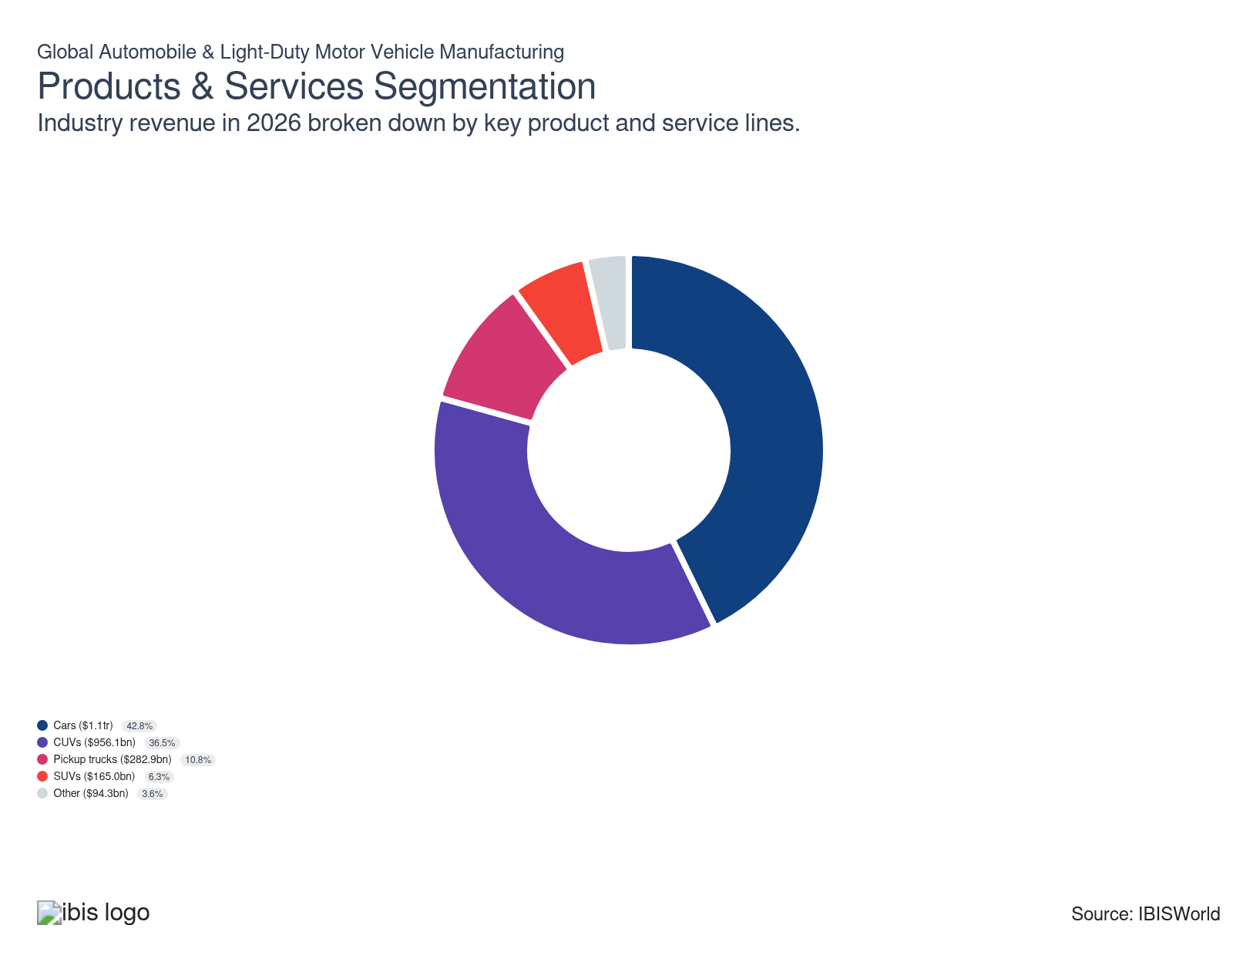

How are the industry’s products and services performing?

Compacts and luxury vehicles fill a wide variety of consumer niches
- This segment caters to many markets. It includes compact, subcompact and midsize cars and luxury and sports cars equipped with gasoline, diesel, hybrid electric or alternative powertrains. For reference, most automakers consider sedans and hatchbacks as compact or midsize cars.
- The wide range of vehicles produced within this segment caters to several target markets. For example, sedans and compacts, like the Toyota Prius and Chevrolet Volt, are popular with consumers more concerned with cost and fuel efficiency.
- Conversely, demand for luxury sedans, like BMW's M-series and Mercedes-Benz's S-class, has grown steadily as high-income consumers consider performance, status and comfort over costs. The luxury subsegment will expand as improving disposable income in developed nations supports these highly discretionary purchases.
- As emerging nations develop infrastructure, demand for this segment, especially compact and midsize vehicles, will blossom; large vehicles, like MPVs, will continue to represent a smaller portion of revenue as consumers prefer the style, horsepower and versatility of SUVs and CUVs. Regardless, sedans are a mainstay in many economies; automakers must maintain a diverse portfolio of compacts, sedans, mid-sizes and larger cars to develop strong, diversified revenue streams.

SUVs and CUVs often appeal to more affluent demographics
- Sport utility vehicles (SUVs) and crossover vehicles (CUVs) are very similar, with more space for occupants and luggage than a passenger sedan and raised ground clearance. SUVs often use a purpose-built chassis for rugged terrain, while CUVs share a chassis with smaller, lighter passenger vehicles to achieve better fuel efficiency. The CUVs' lower cost and greater fuel efficiency have resulted in surging popularity, causing them to account for the vast majority of light truck and light commercial vehicle sales.
- Consistent global per capita income gains have driven affluent buyers toward more luxurious and expensive vehicles like SUVs. Although these vehicles are most popular in more spread-out suburban and rural environments, demand has spread to tighter urban environments. SUVs are particularly popular with families as a stylish alternative to minivans.
- SUV purchases have tapered as fuel prices spike; SUVs often have lower fuel economy, so consumers are more likely to purchase CUVs or compact hybrids when gas prices rise. Many automakers are incorporating fuel-efficient technologies into SUVs, drawing buyers seeking the benefits of a large, family-size vehicle while reducing individual carbon footprint.
- Automakers have attempted to make hybrid and electric CUVs and SUVs with mixed success. Hyundai and GM's core EV models have been well-received while Ford has scrapped plans for a three-row SUV entirely. In general, automakers comparatively maintain a larger fleet of EV sedans.

Pickup trucks have a strong consumer base in the United States
- Most pickup truck sales originate in the United States, particularly rural communities. Pickup trucks are increasingly popular in developing nations with burgeoning construction sectors, like Thailand, where more than 45.0% of vehicles sold were pickups in 2024 (latest data available). Pickup trucks generate comparatively weaker sales in Western Europe.
- Many of these trucks market long life spans, the ability to handle poor road conditions and extensive storage space. These aspects make pickup trucks ideal for supporting manual labor and give them a valuable utility that passenger vehicles and SUVs lack.
- The United States heavily protects its pickup truck manufacturers. Light truck imports, like the Toyota Hilux, face a 25.0% tariff, making them completely unable to compete in the American market. As a result, a high portion of pickup truck manufacturers are in the United States.

Other automobiles fit various specialty roles
- Other vehicles include minivans and specialty vehicles, including firetrucks, ambulances and cutaway buses built on passenger vehicle chassis. This segment also includes executive and city cars along with larger, commercial vans. By definition, this industry excludes vehicles designed to carry more than 10 passengers at once, so larger buses and vans are omitted from this industry.
- Minivan sales have swelled in developing markets like India and South America; these vehicles are less expensive than SUVs and other large vehicles, but have notable cargo and passenger space. In comparison, specialty vehicle sales ebb and flow with government and business investment.

What are innovations in industry products and services?

Companies use new design techniques
- Modern vehicle design processes heavily use computer-assisted design (CAD) software on the manufacturing side of operations. This software enables manufacturers to develop an initial concept and later revisions in days instead of months.
- The latest vehicle assembly plants are either fully or partially automated, with most labor replaced by robotic equipment specialized for a particular vehicle's production. Nations with strong union power have lower automation levels. Korea and Singapore have significantly higher automation levels than other regions, according to the International Federation of Robotics (IFR).
- CAD programs will lead to more uniform product cycles through quicker turnaround times. Many companies also have plans to use generative AI to draft and test new designs. This strategy enables companies to preliminarily test safety, aerodynamics and other factors with computer models.

Companies make advancements in hybrid tech
- Major automotive manufacturers spread their R&D efforts across hybrid, hydrogen and electric vehicle technologies to increase fuel efficiency while reducing greenhouse gas emissions. Hybrid cars present the best market uptake potential because of their relatively low cost compared with other low-carbon-emission vehicles.
- Hybrid vehicles have relatively lower production costs because they use low-capacity batteries; fuel is the primary energy source and the batteries are often supplementary. The internal combustion engine converts the stored chemical energy in the liquid fuel into electric energy, which the car feeds into the battery. The battery then powers the electric motor, which drives the vehicle.
- Plug-in hybrid technology has emerged as an improved form of many existing hybrids. This technology enables vehicle owners to directly recharge their car's battery, reducing a consumer's reliance on fossil fuels. Still, an absence of fueling stations will inhibit the widespread adoption of these technologies in the short run.
- Many automakers have reintroduced vehicle makes and platforms to include hybrid, diesel or electric versions. Automakers have placed a premium on manufacturing lighter vehicles, substituting aluminum for steel as often as possible while working to improve fuel efficiency through electrification systems and transmission enhancements.

Automakers have pushed for autonomous driving
- Many automakers have developed autonomous driving technology, like self-parking and lane departure warning systems. These innovations generally fall under the umbrella of tier 1 automation but some companies have delved into partial and condition automation systems. For instance, adaptive cruise control (ACC) coupled with lane centering is considered tier 2 automation, but ACC alone is not.
- Many technology companies have spearheaded R&D related to conditional and total automation. In particular, Google's Waymo, Apple, Amazon's Zoox and Microsoft all have self-driving competitors. Many rideshare platforms, like Uber and Lyft, have also invested heavily in these technologies, with their business models relying almost entirely on the future of autonomous driving to reduce costs. Most automakers have partnered with one or more of these companies, helping to spread out R&D costs.

What products or services do successful businesses offer?
Establish brand names
Successful automakers have a portfolio of easily recognizable car brands and models, giving these companies a clear competitive advantage. Automakers often emphasize specific qualities in cars, like luxury, safety or cost-effectiveness, depending on the model
Invest in new technology to enhance operational efficiency and quality
Automakers must be prepared to automate and integrate new technologies to streamline production, design and development costs to maximize returns and remain competitive.

Major Markets
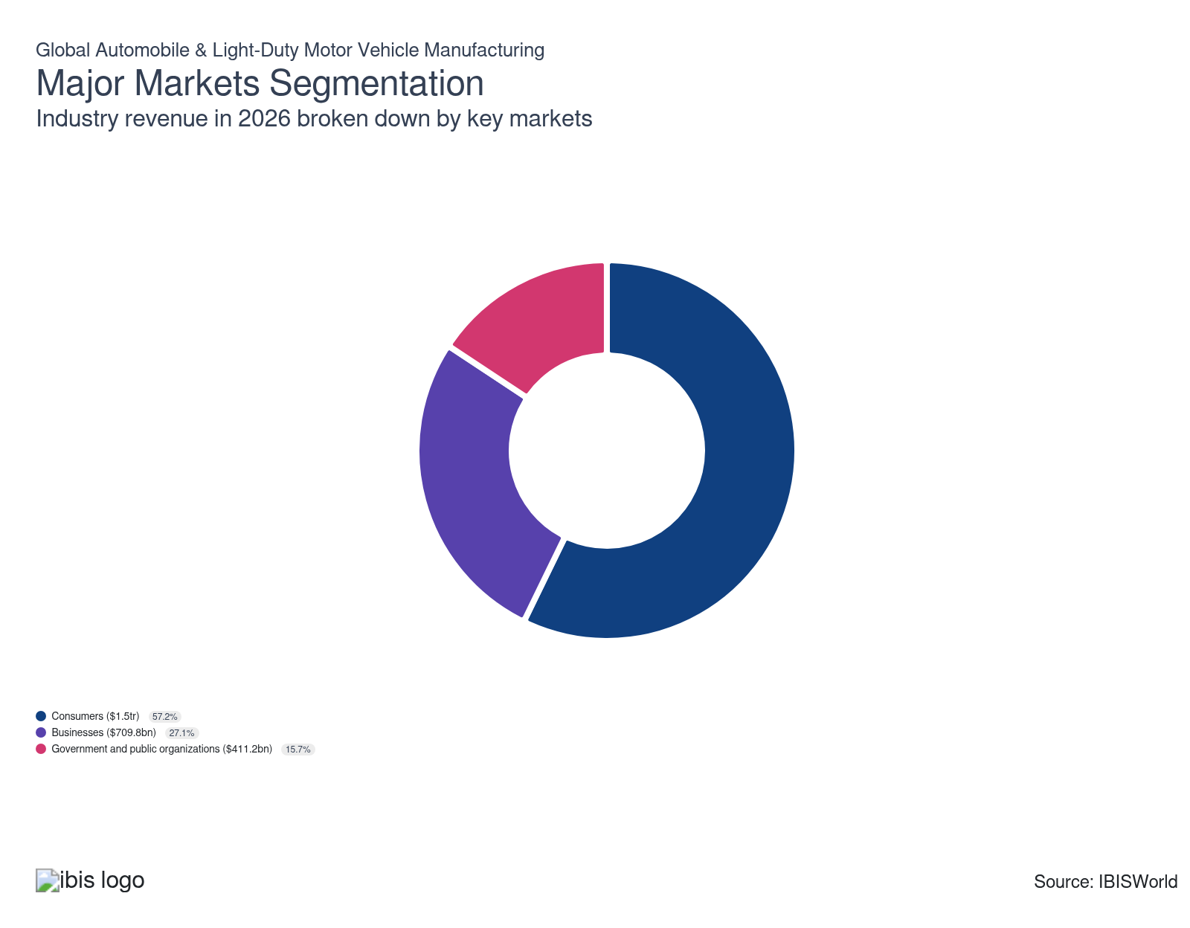

What’s influencing demand from the industry’s markets?

Consumer purchases vary heavily by region
- This market includes mature and developing markets. Mature markets generally encompass Western Europe, North America, Japan, South Korea, Israel, Australia and New Zealand. In general, these consumers have higher disposable incomes, are more likely to own multiple vehicles and trade-in or lease vehicles at much higher rates. These markets account for most sales in dollar terms.
- In comparison, developing markets encompass the majority of rest of the world, notably China, Brazil, Russia and India (BRIC). Automakers often sell lower-value vehicles in developing nations; automakers generate stronger revenue volume in mature markets but have sold higher volumes in developing nations.
- However, preferences in developing markets can vary wildly. According to Asian Automotive Analysis, pickup trucks make up a majority of sales in Thailand while MPVs make up more sales in India; in comparison, Chinese markets more closely mirror developed market tastes. While these countries loosely fall under the World Trade Organization’s developing nation umbrella or self-identify as such, market preferences can heavily vary. As a result, car manufacturers must accurately analyze country-specific demand trends and tailor exports or local production to these variations.
- Following the pandemic, unstable fuel prices have spurred demand for more fuel-efficient vehicles, like compacts, CUVs and hybrids. Many consumers are also considering electric vehicles; however, current EV batteries have a limited battery life, while charging stations are too sparse for EVs to permeate the consumer market in many countries; many East Asian, North American and European countries have more developed charging infrastructure leading to much higher EV adoption rates.
- Also, supply chain shortages have caused car prices to skyrocket, deterring many consumers from purchasing new cars. Similarly, consumer purchases of new vehicles have slowed as inflation heats up and the global economy teeters on the brink of a recession, though economic growth in the latter half of the period has led to strong consumer demand.

Business demand rebounds from the pandemic
- Businesses purchase vehicles for transport to and from job sites, as executive perks or as travel vehicles for business trips. Company cars and equipment truck purchases have increased as corporate profit rebounds after the pandemic; many countries have also faced mounting interest rates through the current period, discouraging businesses from investing in new fleet vehicles.
- Fleet buyers in the developed world will rapidly expand compared with the developing world because of differences in the preferential treatment of motor vehicle-related expenditure in profit and loss statements. Most developed countries enable a full deduction of motor vehicle costs for businesses, catalyzing demand in these lucrative markets.
- The industry also supplies the car rental market with guarantees to repurchase from customers at contractually agreed-upon values, cultivating a longstanding relationship with the global tourism and hospitality industries.
- Again, vehicles in developing nations are often less expensive, generating a lower proportion of revenue than volume sales. As tourism balloons following the pandemic, business demand will skyrocket. Automakers will also sell pickup trucks to construction companies. Manufacturers face a vast disparity between developed and emerging markets and produce a spectrum of trucks to cover each market.

Governments and public organizations provide a steady revenue stream
- Government purchases of vehicles for police and medical purposes can garner extremely high price points and aren't discretionary purchases. For example, governments need firetrucks or police cruisers to protect the public, while some governments also provide ambulatory services to their citizens.
- These vehicles can be extremely costly, but the volume of these vehicles sales is negligible compared with consumer vehicles. Government purchases from manufacturers can also include perks, like tax exemptions and subsidies for securing a lower price, diminishing demand from this crucial market segment.
- Governments worldwide play a relatively minor role in automobile demand, despite policy-driven initiatives promoting the uptake of electric vehicles (EVs), like China's acquisition of EVs for public services. Burgeoning demand for cars in emerging countries has limited the need for government support, curbing the public sector's contribution to automobile sales.

International Trade
Total Imports  $1.1tr  ’21-’26 ↑ 6.8 %  ’26-’31 ↑ 2.0 % | Total Exports  $1.1tr  ’21-’26 ↑ 6.8 %  ’26-’31 ↑ 2.0 % | Trade Balance  Balanced  : $0

International Trade Imports
International Trade Imports
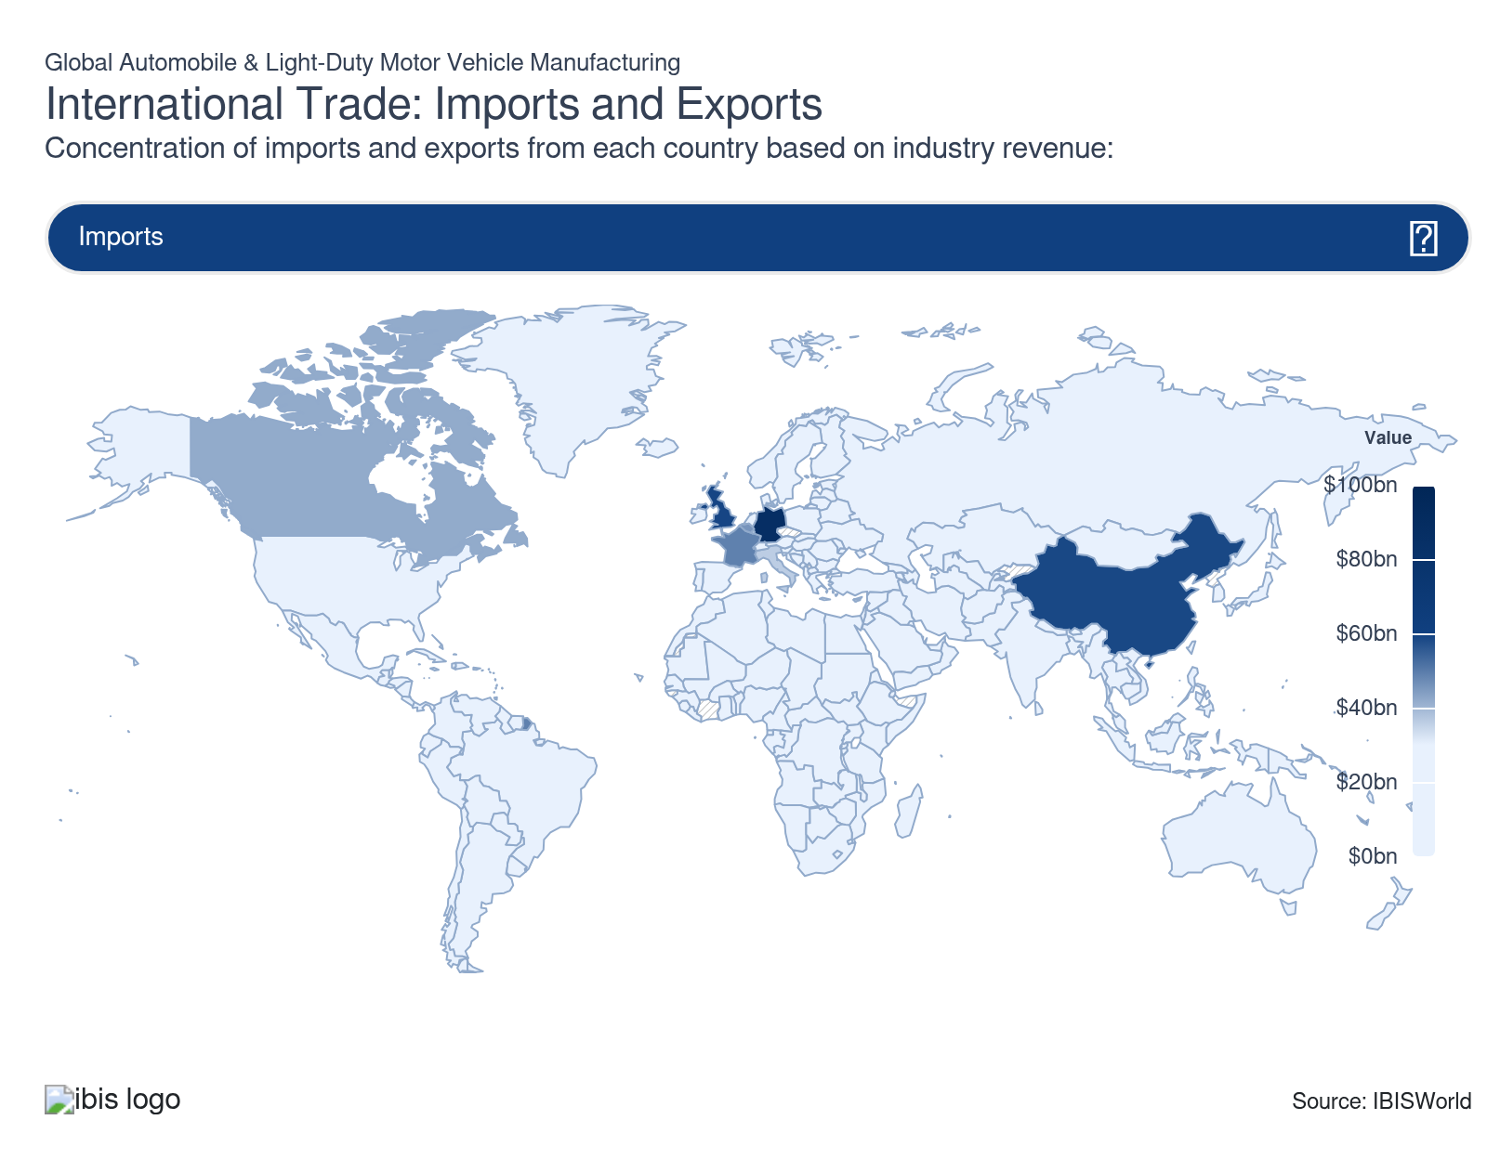
International Trade Exports
International Trade Exports
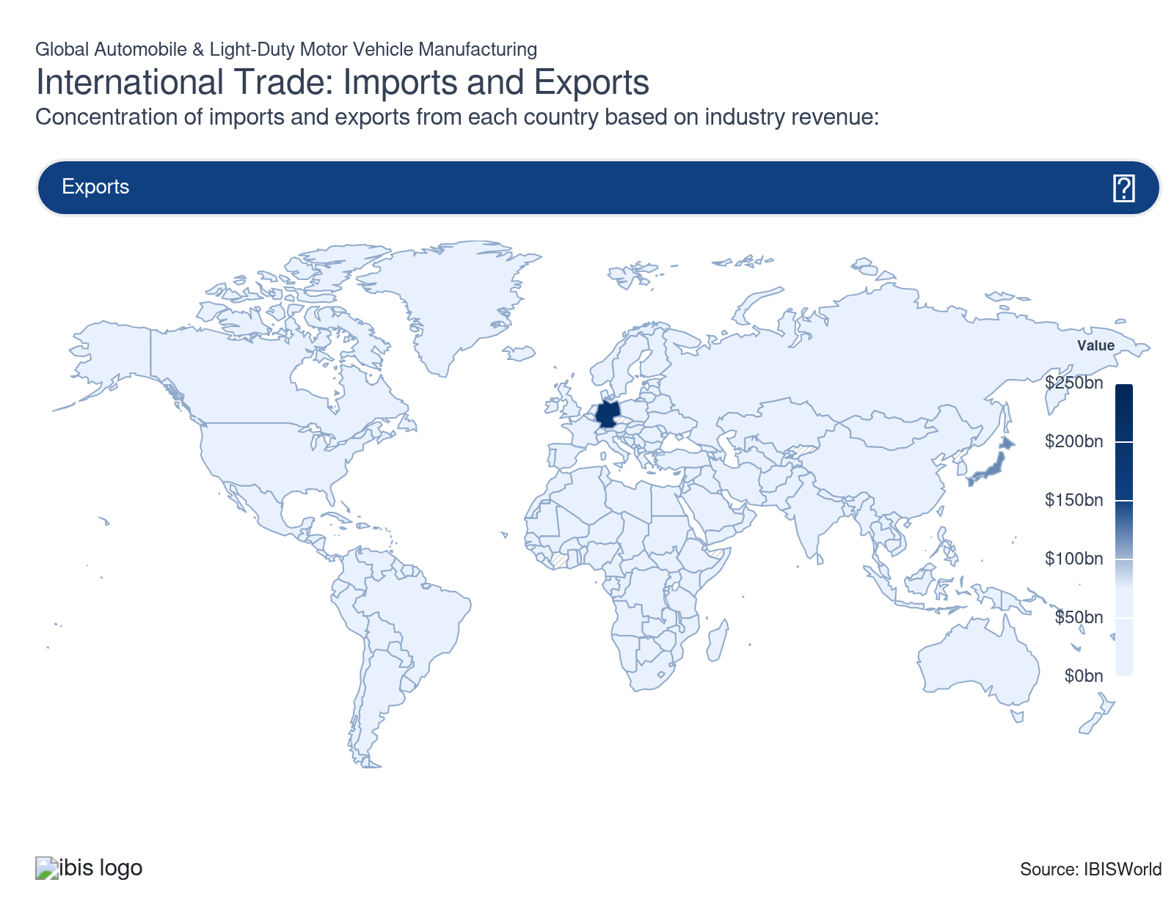

Imports
High | Increasing

What are the industry’s import trends?

Developed nations represent the majority of demand
- Automakers reap the most value from mature markets, like the United States, Germany and the UK. The BRIC nations, especially China, represent a growing source of demand too. Developed nations account for more imports by sales revenue, while emerging economies often generate greater imports by per-unit volumes.
- Consumers in mature markets often purchase luxury and higher-end vehicles more frequently than developing nations. As a result, these economies generate higher overall imports despite selling fewer units. In general, the global car and automobile manufacturing industry is highly globalized, contributing to strong trade volumes.
- In particular, the United States represents one of the industry's largest importers. The country's massive economy and population lend themselves to significant automotive consumption. The country maintains a notable trade deficit, even with significant investment in domestic production from both Big 3 automakers and many Asian manufacturers. Germany, the UK and France are in similar positions, despite also having robust domestic brands.

EU automakers fear tariffs may backfire in Chinese markets
- The European Union has levied countervailing duties on what they deemed “unfairly subsidized” Chinese and other foreign electric vehicles. According to the European Commission, BYD, Geely and SAIC will be bound to 17.0%, 18.8% and 35.3% duties respectively.
- Other cooperating companies face 20.7% duties while the EU also targeted Tesla at 7.8% while non-cooperating companies and countries will receive 35.3% tariffs. The EU also notably placed tariffs on Tesla imports, which had become one of the top EVs in Europe.
- The move passed with some notable dissent. Volkswagen, in particular, lobbied against the tariffs, fearing retaliation. The company, alongside many other prominent automakers, have seen market shares in China plummet and believe retaliatory duties would be the final blow in Chinese markets.

Exports
High | Increasing

What are the industry’s export trends?

German manufacturers pave the way
- German manufacturers dominate the international trade landscape – many prominent luxury brands, like BMW, Audi. Mercedes-Benz and Porsche are German. These primarily companies rely on demand from developed markets, reaping strong returns in many North American, Western European and Asian markets.
- Also, German manufacturers hold a strong position in low-cost markets, leveraging low-priced, fuel-efficient cars, like Volkswagen, Skoda and SEAT. These brands fall under the Volkswagen Group's umbrella, highlighting the company's international power. German cars appeal to many demographics, giving them significant pricing power in the market.
- Other brands also hold significant power across Europe. Specifically, Stellantis' umbrella, including Renault (Dacia), Fiat and Opel, appeal to cost-conscious buyers. Many other VW, Stellantis and Volvo models bridge the gap between discount and premium, creating a robust portfolio and encouraging trade both across European nations and overseas.
- Japanese and South Korean manufacturers also manufacture competitively priced cars that excel in fuel-efficiency and safety, making up the second-largest exporter. The United States and China also represent major automobile exporters; in general, these regions leverage developed manufacturing, technology and automotive sectors to create advanced, cost-effective vehicles that appeal to a wide range of demographics.

China has emerged as a major automotive powerhouse
- China is one of the fastest-growing automotive exporters. Many companies also have joint ventures in the Chinese mainland alongside state-owned companies. China also has several growing electrical vehicle manufacturers, like BYD, Geely and Nio, that supplement Chinese powerhouse, SAIC Motors.
- China has fewer regulations, making it less expensive to produce automobiles. Additionally, the Chinese government has been accused of selling products at unfair prices in foreign markets, hoping to stimulate the automotive industry. The Chinese government has also provided significant funding for promising companies, enabling the massive emergence of BYD and Geely.
- Even so, the US and European Union have each placed significant tariffs on Chinese vehicles, especially electric vehicles. US tariffs wholly restrict Chinese exports, numbering over 125.0% of the original value, while EU tariffs can range from 10.0% to 35.3%. While Chinese brands retain a foothold in EU markets, these models have been largely eliminated from US markets.
- However, tariffs have also threatened popular US, Asian and European brands. For one, these brands maintain significant presences in China, both producing a significant portion of vehicles and generating a large share of sales in China. These policies risk raising car prices and forces companies to reshore production while opening companies up to retaliatory regulations in China, further diminishing already weakening market shares in East Asia.

Nearshoring strategies have been lucrative for many automakers
- Many manufacturers have built facilities in Mexico to create a new point of contact with the United States while accessing less expensive labor than the US. Tesla, Toyota, GM and other major automakers have opened EV manufacturing facilities in Mexico.
- The same strategy has supported production growth in Eastern European nations. In fact, JATO reports that Czechia, Romania, Turkiye and Slovakia were among the top ten for origin of assembly of new passenger cars registered in Europe. Essentially, these non-traditional manufacturing locations offer comparatively inexpensive labor, land and inputs, creating lucrative opportunities for industry leaders to interface with Europe without paying for space in France, Germany, Italy the UK or Spain.
- Asia is also facing this trend, especially with non-Chinese companies. Many brands have invested in Southeast Asia, especially for their vehicle electronics and low-cost models. This strategy enables companies to continue interfacing with the burgeoning Chinese market, without facing tariffs from the US, India, Japan and numerous other nations that would penalize production in China.

5. Geographic Breakdown
https://my.ibisworld.com/gl/en/industry/C2531-GL/geographic-breakdown

Key Takeaways
- Automakers operate near key markets. Many automakers have manufacturing plants across North America, Europe and Asia to cater to developed and emerging markets.
- Many manufacturers have moved to developing economies. These regions often have lower production costs and express swelling demand every year.

Business Locations

Where are industry businesses located?

China is the largest producer of passenger vehicles
- According to data from the International Organization of Motor Vehicle Manufacturers, North Asia is the largest producer of vehicles overall, with China producing more than 30.0% of passenger vehicles globally. For comparison, China accounted for less than 5.0% of passenger and light commercial vehicle production worldwide at the turn of the millennium.
- China's above-average growth and the relatively low labor costs are significant catalysts for the region's expansion. China represents the largest automobile market; despite its production prowess, Chinese manufacturers tailor lower price tags to emerging economies with lower disposable income levels, creating a disparity in the share of Chinese production and revenue generated in the region.
- In particular, China's proprietary brands have grown in power, with companies like SAIC, BYD and Geely satisfying an increasing portion of the country's domestic demand as well as foreign demand. The Wall Street Journal also reports that Chinese automakers only used half of their total capacity in 2024, suggesting that the country can become even more dominant in production. Japan remains a powerhouse with major brands, including Honda, Toyota, Mitsubishi Nissan and Suzuki.
- South Korea also represents a prominent automobile manufacturer, with Hyundai and Kia. South Korea and Japan have developed manufacturing, automotive and technology sectors, creating opportunities for innovation. Companies in these countries have also developed longstanding reputations.

European manufacturers create a wide range of luxury and sport vehicles
- Europe is the second-largest auto producer collectively. Germany leads the region, followed by Spain, France, the UK and Italy. These countries have numerous proprietary automobile manufacturers, including low-cost and luxury brands. Companies have also readily leveraged lower costs and growing incomes in Eastern Europe to expand.
- Many companies in these regions specialize in high-end luxury and sports brands, like BMW, Maserati, Renault, Bugatti and Aston Martin. Many foreign companies also have production facilities in these countries, acting as a point of sale in Europe.
- Automotive manufacturing has steadily grown in Turkey, the Czech Republic and Slovakia. Even so, Russian production has fallen as companies pull out of the region amid the Ukrainian war and sanctions make production impossible.

North American producers lose ground to Asian manufacturers
- North America is the third-largest producer of automobiles and light motor vehicles, led by the United States and Mexico. Canada's car and automobile manufacturing industry has steadily declined following the 2008 recession, though minor growth in SUV and light truck manufacturing has buoyed Canada's auto sector.
- Production in this region has slowly shifted toward Mexico as low labor costs and less costly overhead costs have attracted more US-based companies. Even so, the USMCA has pushed for higher labor standards, slightly constraining growth in Mexico. In particular, the new US president may influence policy towards Mexico, encouraging companies to reshore in the US.
- While Mexican production is on the rise, this increased capacity is primarily in the realm of passenger vehicles. The United States remains a bastion of light commercial vehicle production, including pickup trucks, sport utility vehicles and crossovers.
- In general, the region has lost production share to Asia over the past two decades. In 2000, the United States and Canada alone represented nearly 30.0% of global output; this figure has fallen to just 13.0% in 2025.

Other regions are primed to blossom
- Although currently low, Southeast Asia and India have the potential to become major powerhouses in motor vehicle production over the next decade. Increasing car ownership in these regions, coupled with favorable government regulations and support, have encouraged multinational automobile manufacturers to invest in this region.
- In particular, tariffs against Chinese EVs from many North American and European Union countries may encourage some manufacturers to explore production in this region. This trend would mirror offshoring trends in global consumer electronics and semiconductor industries.
- India alone accounts for nearly 8.0% of global production in 2025, though this proportion will skyrocket as the burgeoning middle class demands new cars and sport utility vehicles. Growth from Tata Motors and its subsidiary Jaguar Land Rover will create opportunities in Central Asia.
- While every continent has seen an uptick in vehicles in use, according to the OICA, Asia and Africa have seen the highest rates of increase. This factor may encourage more companies to set up satellite facilities in these burgeoning locations to reduce transportation costs.
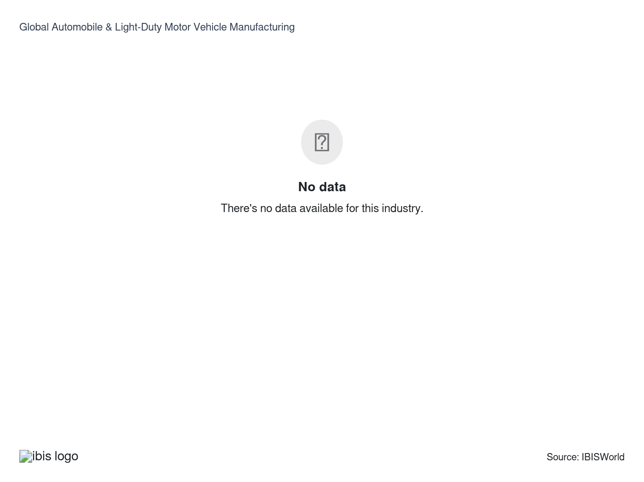

How do businesses use location to their advantage?
Operate in a location that is close to key markets
Companies can reduce transportation costs by operating near key markets. Many companies have established satellite facilities in low-cost regions near major markets.
Operate in a location that is close to key suppliers
Most automakers have locations, particularly research and development facilities, near major suppliers to collaborate on designs and input needs.

6. Competitive Forces
https://my.ibisworld.com/gl/en/industry/C2531-GL/competitive-forces

Key Takeaways
- The industry's dominant automakers maintain control. High per-unit and start-up costs, combined with established producers' scope and power, make it virtually impossible to join the industry.
- Automakers are prioritizing eco-friendly solutions. Companies that can excel in burgeoning EV and hybrid markets will attract new consumers. Some entrants like Rivian and Lucid have found niche success, earning significant investment from other automakers and other investors.

Concentration
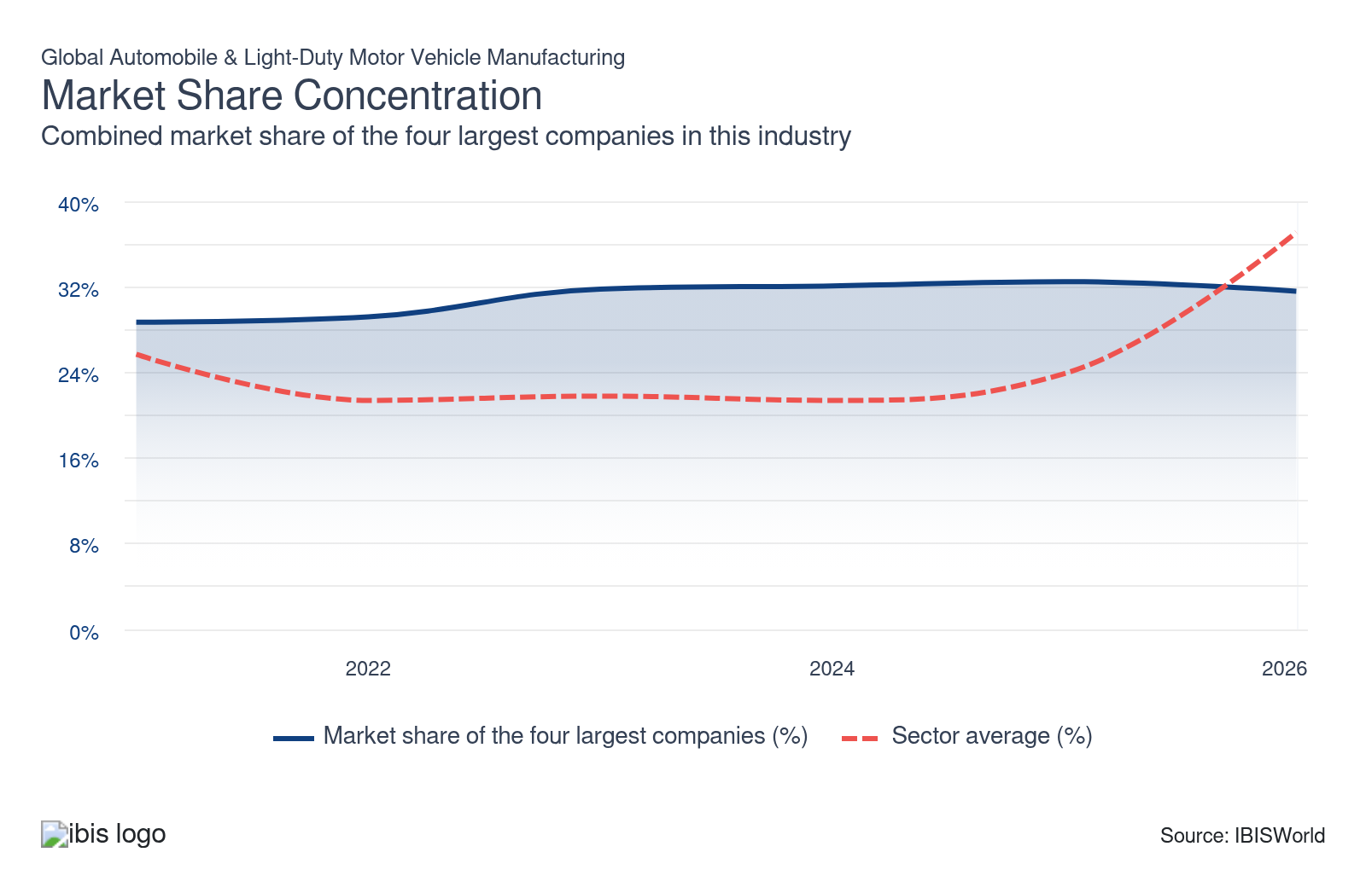

What impacts the industry’s market share concentration?

Major automakers span multiple demographics
- The industry's largest automakers operate multiple product lines that appeal to different markets, income levels and personal preferences. These companies have established stellar reputations, becoming household names with many consumers.
- For example, Volkswagen's flagship passenger cars often appeal to cost and environmentally-conscious consumers, while its subsidiaries, Audi, Lamborghini, Porsche and Bentley, appeal to wealthy consumers, mostly in developed nations.
- Most prominent manufacturers display similar reach, making it difficult for smaller companies to usurp incumbents. Many smaller automakers can find success as contract manufacturers, helping large automakers streamline processes.

Automakers actively consolidate
- Automakers have readily consolidated to increase profit and market reach. Through May 2023, global automotive M&A totaled more than $40.0 billion. According to PwC, deal volume has slowed following high points during the pandemic.
- Many companies have targeted electric vehicle companies rather than developing proprietary EV and hybrid technology. According to Ford CEO Jim Farley, EV investment will require massive amounts of capital, necessitating consolidation.
- Similarly, many companies have partnered with EV brands to create affordable electric vehicles. For example, General Motors and Chinese automakers SAIC and Wuling have partnered to create China's top-selling Hongguang Mini EV. Similarly, the SAIC-Volkswagen partnership accounts for a notable portion of SAIC's revenue.
- However, the massive Honda-Nissan merger has fallen apart while no other major M&A has occurred since the PSA-FCA merger. Instead, companies have found greater success acquiring ancillary competitors, upstream suppliers and other companies that provide cost or technology synergies.

The industry is extremely concentrated
- Leading automakers are highly concentrated; automakers are well-established with strong market positions. Disruptors, like Rivian or Lucid, often struggle to find commercial success; however, Tesla and BYD, for example, have developed strong, highly successful and profitable brands in the EV space.
- Automakers maintain extensive partnerships and alliances with one another. For example, Ford and Volkswagen both have significant investments in Rivian, Toyota and BMW have a long-standing partnership, Hyundai and Kia are core partners while Renault, Nissan and Mitsubishi have an alliance. At the same, time, automakers often have a wide umbrella of name brands; for instance, GM owns GMC, Chevy, Cadillac and many other easily recognizable names.

How do successful businesses handle concentration?
Secure the latest available and most efficient technology and techniques
Automakers must be prepared to automate and integrate new technologies to streamline production, design and development costs to maximize returns and remain competitive.
Establish brand names
Successful automakers have a portfolio of easily recognizable car brands and models, giving these companies a clear competitive advantage. Automakers often emphasize specific qualities in cars, like luxury, safety or cost-effectiveness, depending on the model

Barriers to Entry
High | Steady

What challenges do potential industry entrants face?

Legal
- Companies navigate a complex regulatory environment. Most automakers adhere to the strictest regulations, often in the US, Japan or the EU, to access the widest range of markets. These regulations have increased alongside harmonization efforts. Automakers also traverse a minefield of international patent and intellectual property regulations. Tariffs can also create various legal pressures.

Differentiation
- Brand names are entrenched in consumer markets, stemming from decades of marketing and widespread consumer loyalty. Automakers compete to create safer, more fuel-efficient and luxurious vehicles at competitive price points. Each consumer demographic values different traits, so manufacturers must constantly adapt to changing tastes. Awards, like the J.D Power or Kelly Blue Book, can help a company differentiate in certain markets.

Start-up Costs
- Entrants endure massive start-up costs. Incumbents benefit from optimally scaled high-volume production facilities, requiring extensive investment. Automakers must purchase high-tech machinery for assembly line processes and multiple manufacturing and storage facilities. Increased technological requirements havemade it nearly impossible for entrants to exist in the automotive space, especially given lengthy periods before profitability, as shown by Tesla, Lucid and Rivian in the United States.

Capital Expenses
- Manufacturers have a high capital intensity. Companies constantly invest in new technology and R&D opportunities. In particular, hybrid propulsion systems and flexible-fuel technologies offer the most lucrative areas of development, but this cutting-edge technology carries significant R&D costs. Companies must also retool product lines for the latest technologies and models, creating constant depreciation expenses.

How can potential entrants overcome barriers to entry?
Flexibility in determining expenditure
Controlling employee-related costs, like health and pension costs, makes manufacturers in the developed world more competitive.
Use the most efficient work practices
Good union relations through a motivated workforce assist in minimizing union disputes.
Secure the latest available and most efficient technology and techniques
Automakers must be prepared to automate and integrate new technologies to streamline production, design and development costs to maximize returns and remain competitive.

Substitutes
Low | Steady

What are substitutes for industry services?

Bikes, scooters and motorcycles
- Bikes, scooters, motorcycles and other similar transportation methods have a higher market share in developing economies, although the rise in inexpensive motor vehicle production may reverse this trend. In Southeast Asia and South America, bicycles and motorcycles are a more convenient option for consumers, given often narrow and crowded streets and roads.
- These transportation methods offer a far less expensive alternative to automobile ownership. In addition, these modes of transport are frequently considered cleaner and more environmentally friendly in some mature markets, like Europe, supporting competition even in these historical bastions of demand.
- Regardless, bikes and motorcycles fill a different recreational niche in developed economies; these products have no storage options and leave riders exposed to the weather. Even so, hybrid and electric vehicles are growing in popularity and may help attract more environmentally conscious buyers, mitigating this threat.

Mass transportation
- For many consumers, mass transportation is a simple, cost-effective transportation method. In many cities, like New York City, Hong Kong or Rome, cars are cumbersome and expensive to maintain and store. Public transportation is simply more efficient in many large cities.
- Some cities have subpar public transportation, necessitating cars. Even so, many consumers gravitate toward mopeds or bikes in major, crowded cities, citing lower costs. In fact, many cities have prioritized biking lanes and other public infrastructure, pushing people away from cars.

How do successful businesses compete with substitutes?
Establish brand names
Successful automakers have a portfolio of easily recognizable car brands and models, giving these companies a clear competitive advantage. Automakers often emphasize specific qualities in cars, like luxury, safety or cost-effectiveness, depending on the model
Undertake technical research and development
Automakers have rapidly innovated more fuel-efficient vehicles to push back on rising competition from external substitutes, like public transportation and bicycles.

Buyer & Supplier Power
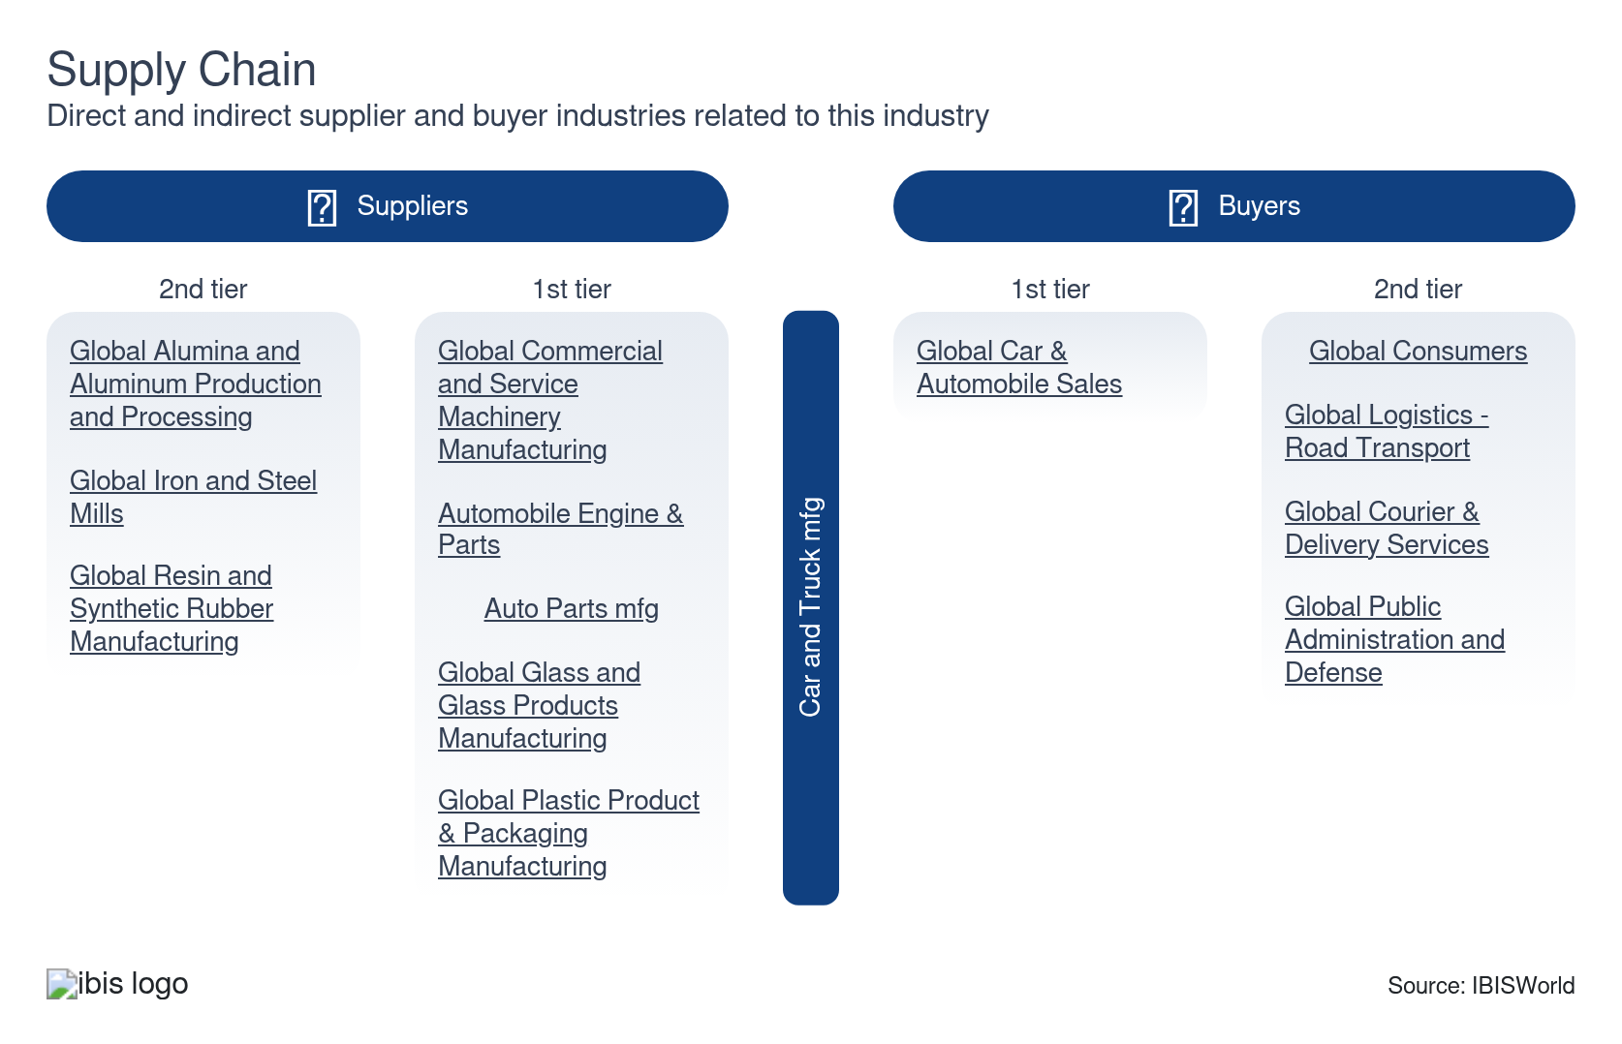

What power do buyers and suppliers have over the industry?

Buyers: Consumers express high brand loyalty
Moderate | Steady
- Most consumers purchase vehicles they already know, barring poor driving or safety experiences, giving automakers more power. Different demographics also exhibit particular purchasing habits. For example, families gravitate toward the highest safety-rated cars, while single adults may prefer sports cars and luxury vehicles.
- Many consumers also purchase domestic cars; for instance, American consumers are most likely to buy a Jeep or Chevy while German buyers are more inclined toward Volkswagen or BMW. National pride and dogma can be major driving forces in car sales. Even so, buyers have increasingly prioritized price, luxury or safety, depending on their demographic, and weigh different options before buying. This has led to Honda, Hyundai and Toyota growing more popular in North American markets.
- Many consumers have also emphasized carbon footprints, encouraging companies to develop hybrids and electric vehicles. This growing market niche has disrupted some brands, as more consumers shift toward Tesla, BYD and other fully electric brands.

Suppliers: pricing power varies by supplier and input type
Moderate | Steady
- Steel, aluminum and glass manufacturers display low pricing power. Since supply chains are highly globalized, automakers can freely shop for the lowest price on these inputs. Many automakers have notable control over various auto parts industries, often displaying some level of vertical integration or maintaining strategic partnerships.
- On the other hand, automakers may be hesitant to change suppliers for auto electronics and other advanced parts. Most of these parts are highly specific and the costs associated with switching contractors can be unappealing. This trend often results in a single automaker making up the majority of revenue for auto parts contractors.
- Automakers have less negotiating power with semiconductor companies. Many manufacturers rely on a handful of semiconductor manufacturers, like NVIDIA and NXP; recent supply shortages have forced many automakers to retract just-in-time semiconductor ordering systems. Many automakers have developed partnerships with semiconductor manufacturers for EV and self-driving vehicle testing.

How do successful businesses manage buyer & supplier power?
Developing effective cost controls
A close relationship with suppliers and good distribution channels assist in controlling costs. Companies often develop contracts and partnerships with key suppliers.
Develop a symbiotic relationship with another industry
Automakers have increasingly partnered with key suppliers to create more advanced products. Many automakers have also vertically integrated with auto parts manufacturers.

7. Companies
https://my.ibisworld.com/gl/en/industry/C2531-GL/companies

Key Takeaways
- Automakers have increasingly focused on sustainability. Companies that can produce the most environmentally friendly vehicles will gain ground as consumer preferences shift and regulations tighten.
- Companies readily acquire successful brands and innovative technologies. Successful manufacturers have also partnered with tech companies and other manufacturers to produce cutting-edge vehicles.
- Leading brands dominate the global car and automobile manufacturing landscape. Some entrants have found success in the EV and hybrid markets but the industry is largely made up of dominant conglomerates with set markets and strong brand reputations.

Market Share
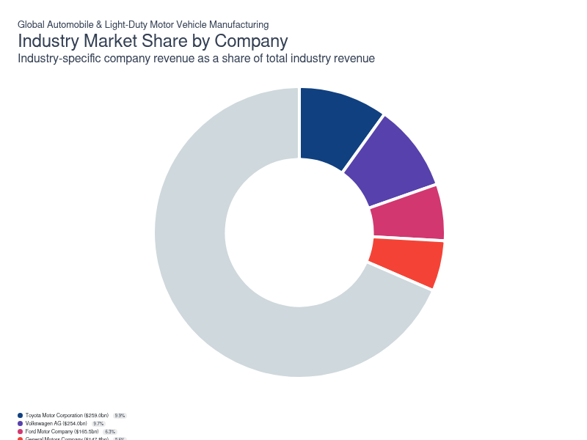
Chart displays current year only in the PDF version of this report. You can view and download chart for all other years associated with this industry on my.ibisworld.com.

Companies
Company | Market Share (%)  2026 | Revenue ($m)  2026 | Profit ($m)  2026 | Profit Margin (%)  2026
Toyota Motor Corporation | 9.9 | 258,975.9 | 19,891.3 | 7.7
Volkswagen AG | 9.7 | 254,039.4 | 15,728.1 | 6.2
Ford Motor Company | 6.3 | 165,505.5 | 4,908.8 | 3.0
General Motors Company | 5.6 | 147,788.6 | 8,903.9 | 6.0
Stellantis NV | 5.1 | 133,204.1 | 9,695.0 | 7.3
Hyundai Motor Company | 5.0 | 130,830.7 | 9,532.9 | 7.3
Mercedes-Benz Group AG | 4.4 | 115,859.0 | 12,045.7 | 10.4
BYD Company Limited | 3.8 | 98,325.7 | 4,973.8 | 5.1
Honda Motor Company Ltd. | 3.5 | 92,964.3 | -970.2 | -1.0
Kia Corporation | N/A | N/A | N/A | N/A
Nissan Motor Co. Ltd. | 2.8 | 72,883.0 | 1,608.4 | 2.2
Tesla, Inc. | N/A | N/A | N/A | N/A
SAIC Motor Corporation Limited | 2.2 | 58,728.7 | 1,838.2 | 3.1
Tata Motors | 1.4 | 37,270.0 | 372.1 | 1.0

Toyota Motor Corporation
Toyota Motor Corporation
Company Details
Company Details
Industry Specific Revenue (2026) | $259.0bn
Industry Profit (2026) | $19.9bn
Market Share (2026) | 9.9%

Description
Description
Toyota Motor Corporation (Toyota) is a Japanese multinational corporation founded in 1937. Headquartered in Aichi, Japan, most company employees work at manufacturing facilities in Asia and North America. Globally, Toyota produces automobiles and car parts in nearly 30 countries. The company operates in the industry through its automotive segment through its Toyota, Lexus and Daihatsu nameplates.
The Toyota line offers passenger cars, minivans and commercial vehicles. Its Daihatsu Motor Co. Ltd. subsidiary produces and sells mini-vehicles and compact cars, while Lexus is the company's line of luxury passenger vehicles. The company also manufactures automotive parts, components and accessories for use and sale to others, although these are also omitted from industry-relevant revenue estimates. Toyota's core products are small- and mid-size cars; it controls most of the US hybrid market through its first-mover advantage. The Prius has been on the market since 1997, long before the public acceptance of hybrid technology, instilling brand recognition for over two decades in the hybrid space.

Brands and Trading Names
Brands and Trading Names
- Lexus
- Toyota

Other Industries
Other Industries
- GLGlobal Automobile Engine & Parts Manufacturing

Company’s Industry Revenue, Market Share, and Profit Margin Over Time
Company’s Industry Revenue, Market Share, and Profit Margin Over Time
Year | Industry Revenue ($ million) | Market Share (%) | Profit Margin (%)
2020 | 186762 | 8.6 | 8.1
2021 | 180591 | 7.8 | 9.5
2022 | 202079 | 8.5 | 7.3
2023 | 232899 | 9.4 | 11.9
2024 | 246553 | 10.1 | 10.0
2025 | 258976 | 10.2 | 7.7
2026 | 258976 | 9.9 | 7.7

What's impacting Toyota Motor Corporation's performance?

Toyota announces new facilities and partnerships
- The company has invested heavily in developing and improving several global manufacturing facilities over the past five years and signing several new partnerships. Specifically, in 2019, Toyota announced a $600.0 million investment in the mobile ridesharing platform DiDi Chuxing as some automakers seek to develop proprietary ride-hailing services along with purpose-built vehicles used for these services. Toyota and Mazda invested $2.3 billion in a joint venture in Alabama in 2020 to bring more manufacturing capacity to the region. The company plans to invest another $383.0 million in four US manufacturing plants to support the production of four-cylinder engines and hybrid electric vehicles beginning in 2022.

Toyota implements generative AI technology
- Toyota has unveiled its latest streamlining technology: generative artificial intelligence to improve the time-consuming vehicle design phase. While designers have previously used AI, most programs fail to account for safety and engineering limitations. This new program can implicitly incorporate engineering principles, like drag for fuel efficiency and ride height for safety. Developers can request ergonomic designs from the AI with simple text prompts, saving an immense amount of time and enabling Toyota to allocate labor elsewhere.

Toyota maintains partnership with BMW
- Toyota has maintained a long-term strategic partnership with BMW since 2011, jointly advancing the development of environmental technologies, including fuel cells and sports cars. The company re-upped its partnership in September 2024, signing an agreement to strengthen collaboration in the hydrogen sector. Toyota and BMW represent two of the leaders in commercial and passenger vehicle hydrogen fuel cell technology.
Volkswagen AG
Volkswagen AG
Company Details
Company Details
Industry Specific Revenue (2026) | $254.0bn
Industry Profit (2026) | $15.7bn
Market Share (2026) | 9.7%

Description
Description
Volkswagen AG (Volkswagen) is a leading manufacturer of passenger cars, light commercial vehicles, trucks, buses and motorcycles. The organization was founded in 1937, is headquartered in Wolfsburg, Germany and operates 120 production facilities in 29 countries. Volkswagen's industry-relevant automotive division comprises a wide range of brands catering to various target markets. Some of the brands managed by the company include Audi, Bentley, Lamborghini, Porsche, SEAT, SKODA and Volkswagen's passenger cars and commercial vehicles.

Brands and Trading Names
Brands and Trading Names
- Audi
- Bentley
- Ducati
- Lamborghini
- Porsche
- Scania
- SEAT
- Volkswagen

Other Industries
Other Industries
- GLGlobal Automobile Engine & Parts Manufacturing

Company’s Industry Revenue, Market Share, and Profit Margin Over Time
Company’s Industry Revenue, Market Share, and Profit Margin Over Time
Year | Industry Revenue ($ million) | Market Share (%) | Profit Margin (%)
2021 | 204417 | 8.9 | 7.5
2022 | 199046 | 8.4 | 7.7
2023 | 236285 | 9.5 | 6.7
2024 | 233013 | 9.6 | 5.3
2025 | 254202 | 10.0 | 1.6
2026 | 254039 | 9.7 | 6.2

What's impacting Volkswagen AG's performance?

Volkswagen embroiled in recent emissions scandal
- Scandal rocked the company just before the current five-year period when regulators uncovered that Volkswagen equipped 11.0 million Volkswagen vehicles software that helped it cheat emissions tests. The software reduced the measured emissions of diesel-powered passenger vehicles during official testing. When the software was inactive, emissions would skyrocket to nearly 40 times that of the recorded results at testing. Regulators forced Volkswagen to recall the 11.0 million affected vehicles and to pay $15.0 billion to US authorities and owners of affected vehicles. The organization shed 30,000 workers in the wake of the discovery as it looked to cut costs to pay for the massive fine and electrify its portfolio. This incident severely damaged Volkswagen's reputation.

Volkswagen announces new facility in North America
- The company has strategically pushed to enhance and grow its brands via electric and digital transformation. For example, in March 2022, Volkswagen announced it plans to invest $7.1 billion in research, development and manufacturing in North America with the main goal of phasing out gas-powered vehicles while simultaneously boosting production of electric vehicles (EV) in the region. The company aims for 55.0% of all US sales to be fully-electric by 2030.

Volkswagen forges relationships with key suppliers and competitors
- Volkswagen recently formed several joint ventures with Asian producers and refiners of nickel, cobalt and other key materials necessary for EV production. Volkswagen formed another joint venture with Rimac when it sold the Bugatti brand to them in 2021. This business relationship aims to produce electric-powered, luxury hyper sports cars. VW also maintains a working relationship with SAIC Motor.

Volkswagen announces strategic EV shift
- Mounting pressure from Chinese EV and ICE manufacturers, labor strikes and overall unfavorable conditions have forced Volkswagen to shift short and long-term plans to get profitability back on track after passenger vehicle revenue and operating profit dipped through the third quarter of 2024 compared to YTD 2023. The company plans to create low-cost compact electrics in Wolfsburg starting in 2027; these cars would cost under $25,000, marking a major move toward low-cost EVs. This strategy would renew competition between Chinese EV makers, Stellantis and other companies chasing the title of least expensive EV.
Ford Motor Company
Ford Motor Company
Company Details
Company Details
Industry Specific Revenue (2026) | $165.5bn
Industry Profit (2026) | $4.9bn
Market Share (2026) | 6.3%

Description
Description
Ford Motor Company (Ford) was founded in 1903 and is a Michigan-based staple of the automotive world. The company produces midsize cars, sport utility vehicles (SUVs) and pickup trucks in its numerous manufacturing and assembly plants in Canada, Germany, Mexico, the UK and the United States. More than two-thirds of the company's manufacturing capacity is in North America. Ford employs more than 183,000 workers and operates in countries, like China through joint ventures, including Changan Ford Mazda Engine. However, it lags behind Volkswagen and General Motors regarding market penetration in the region.

Brands and Trading Names
Brands and Trading Names
- Ford
- Lincoln

Other Industries
Other Industries
- GLGlobal Automobile Engine & Parts Manufacturing

Company’s Industry Revenue, Market Share, and Profit Margin Over Time
Company’s Industry Revenue, Market Share, and Profit Margin Over Time
Year | Industry Revenue ($ million) | Market Share (%) | Profit Margin (%)
2021 | 114530 | 5.0 | -0.2
2022 | 135469 | 5.7 | 2.5
2023 | 148895 | 6.0 | 2.8
2024 | 155493 | 6.4 | 2.3
2025 | 163788 | 6.5 | 1.7
2026 | 165506 | 6.3 | 3.0

What's impacting Ford Motor Company's performance?

Ford-SK partnership awarded $9.2 billion loan from the US government
- The US Department of Energy has awarded the Ford-SK partnership with a groundbreaking $9.2 billion to produce three battery plants in Tennessee and Kentucky. The loan comes from the US government's Advanced Technology Vehicles Manufacturing (ATVM) loan. The new plants will likely create more than 5,000 jobs in Tennessee and 6,500 jobs in Kentucky while advancing Ford's electric vehicle mission. Ford will also take advantage of tax credits written into the Inflation Reduction Act; the company expects to reap more than $7.0 billion in tax credits.

Ford shifts focus to electric vehicles, cutting US workforce
- Automakers have faced complex transitions and tough decisions as they navigate the ballooning electric vehicle market. Ford has already separated its combustion engine and EV divisions, hoping to improve company-wide efficiency. Even so, Ford's EV business is extremely unprofitable, expected to bleed $3.0 billion in operating profit in 2023. Even so, Ford readily believes that the greatest long-term returns lay in the EV market and continues to invest in those departments, cutting funding for its traditional combustion-engine business to recoup the EV business' losses.

Ford delays new EV plants
- Ford has announced plans to delay its latest EV plant, entirely scrapping plans for a three-row all-electric SUV. The move comes amid Ford's consistent struggles to develop its presence in US and global EV markets, largely falling behind GM and various Asian and European manufacturers. These other companies have found greater success with hybrid and fully-electric SUVs. Ford has instead prioritized hybrid vehicles, hoping to enhance short-term profitability and re-enter the market with a more stable capital base.

Ford logs massive EV loss in 2025, further delaying EV transition
- Ford has reported a loss upward of $19.5 billion through 2025, associated primarily with its EV business, including closure and repurposing of several battery plants and the breakup of the SK Group joint venture. While the company remains on track to produce several EV models, Ford has considered scrapping many others, including the F-150 Lightning in favor of an extended-range, fuel-efficient gas upgrade. Ford states that the aim is to exit loss-making assets and shift capital previously earmarked for EVs into higher-margin models. This shift will mark greater investment in ICE technology, including hybridization and fuel injection.
General Motors Company
General Motors Company
Company Details
Company Details
Industry Specific Revenue (2026) | $147.8bn
Industry Profit (2026) | $8.9bn
Market Share (2026) | 5.6%

Description
Description
General Motors Company (GM) was founded in 1908 and is headquartered in Detroit. The organization employs 157,000 workers in its numerous manufacturing, assembly, distribution, office and warehousing operations in 29 countries. GM principally locates its Vehicle manufacturing and assembly operations in Brazil, Canada, China, Mexico, South Korea and the United States. The most recognizable brands manufactured and marketed by the company include Buick, Cadillac, Chevrolet and GMC. GM generated an expected $161.1 billion in total revenue across its global business in 2023.
The company segments its business into four divisions: GM North America (GMNA), GM International (GMI), cruise and GM Financial. Although GM provides some financial services, the company derives more than 85.0% of its revenue from automobiles and light trucks. This proportion is shrinking each year as its financial arm expands.

Brands and Trading Names
Brands and Trading Names
- Buick
- Cadillac
- Chevrolet
- GMC

Other Industries
Other Industries
- GLGlobal Automobile Engine & Parts Manufacturing
- Automobile Engine & Parts Manufacturing in Canada
- Automobile Wholesaling in Canada

Company’s Industry Revenue, Market Share, and Profit Margin Over Time
Company’s Industry Revenue, Market Share, and Profit Margin Over Time
Year | Industry Revenue ($ million) | Market Share (%) | Profit Margin (%)
2021 | 98874 | 4.3 | 7.3
2022 | 119728 | 5.0 | 6.6
2023 | 134675 | 5.4 | 5.4
2024 | 147371 | 6.0 | 6.8
2025 | 144727 | 5.7 | 4.0
2026 | 147789 | 5.6 | 6.0

What's impacting General Motors Company's performance?

General Motors sunsets the classic Chevy Camaro
- General Motors announced its intent to sunset its Chevrolet Camaro following the 2024 model year, marking the end of one of the last affordable American sports cars. Dodge has already discontinued its Challenger and Charger models, making Ford Mustangs the last high-profile sport-muscle car. The move will permit GM to focus on more profitable models, particularly crossovers and SUVs. The writing was on the wall for the Camaro; fewer people are purchasing these sports cars each year. Also, new US regulations require an automaker's fleet to average 49 miles per gallon (mpg) by 2026. The Camaro averages 22 mpg. General Motors plans to reintroduce the Camaro with a more sustainable combustion engine or as a fully electric alternative but currently has no timeline for this plan.

GM displayed robust EV sales growth before the end of the EV rebates
- GM has reported highest-ever sales on most EV models in Q4 of 2024, with EV sales in the US up 37.0% from Q3 2024 and yearly EV sales easily eclipsing 2023 totals. EVs drove growth in Cadillac especially, with the LYRIQ driving the subsidiary's best sales volumes since 2016, according to GM. The company's robust EV growth in 2024, positions it for greater expansion, enabling the company to compete with Toyota, Hyundai and Kia in the US market and abroad. GM has had more trouble getting sustainable EV sales abroad. However, the company expects lackluster EV performance in Q4 2025 and 2026 given the end of EV rebates in the United States.
Stellantis NV
Stellantis NV
Company Details
Company Details
Industry Specific Revenue (2026) | $133.2bn
Industry Profit (2026) | $9.7bn
Market Share (2026) | 5.1%

Description
Description
In January 2021, Peugeot SA (PSA) merged with Fiat Chrysler Automobiles NV (FCA), creating Stellantis NV (Stellantis). As the surviving company from the merger, FCA cars and light trucks market under the Chrysler, Jeep and Dodge brands. It also offers financial services through its subsidiary Chrysler Capital. Similar to the General Motors Company and the Ford Motor Company, Stellantis' core products are light trucks and sport utility vehicles.

Brands and Trading Names
Brands and Trading Names
- Alfa Romeo
- Chrysler
- Citroen
- Dodge
- DS Automobiles
- Fiat
- Jeep
- Maserati
- Opel
- Ram

Other Industries
Other Industries
- GLGlobal Automobile Engine & Parts Manufacturing

Company’s Industry Revenue, Market Share, and Profit Margin Over Time
Company’s Industry Revenue, Market Share, and Profit Margin Over Time
Year | Industry Revenue ($ million) | Market Share (%) | Profit Margin (%)
2021 | 147214 | 6.4 | 113.0
2022 | 157473 | 6.6 | 11.3
2023 | 172272 | 6.9 | 11.8
2024 | 134483 | 5.5 | 2.5
2025 | 131298 | 5.2 | 0.2
2026 | 133204 | 5.1 | 7.3

What's impacting Stellantis NV's performance?

Stellantis opens the door for new self-driving technology
- In August 2017, the former FCA announced a partnership with Bayerische Motoren Werke AG (BMW) and software and semiconductor manufacturers Intel Corporation and Mobileye NV to develop an autonomous driving platform. Stellantis has maintained its partnership with BMW, joining forces to create a successful level 3 autonomous driving platform. This third level is conditional automation; the vehicle has environmental detection and can operate in most conditions but requires human override and intervention. Stellantis will use this new technology to create a new revenue stream. Many car manufacturers hide more advanced and luxurious features behind a paywall while offering a lower-tech base model at advertised prices.

Stellantis and Foxconn announce recent joint venture
- Stellantis and Taiwanese electronics manufacturer Foxconn have created a 50/50 joint venture, SiliconAuto, to create high-tech semiconductor chips. The venture will supply Stellantis and other automakers with chips starting in 2026. Stellantis will use the chips in its STLA Brain electrical/electronic and software architecture for its self-driving vehicles. The company will also benefit from a stable supply of essential semiconductor components; major semiconductor shortages plagued the industry following the pandemic.

Stellantis NV and Samsung SDI form a joint venture
- Stellantis NV and Samsung SDI will form a joint venture for North America's lithium-ion battery cells and module production. This is targeted to start in 2025. This action will allow Stellantis to be well-positioned to compete and ultimately succeed in the North American electric vehicle market. The company deems this as a critical investment in the collective future.

Stellantis hires new CEO, shifts focus to prioritize long-term growth
- Stellantis saw overall profit and revenue tank through 2024 and 2025, with the CEO's removal. With CEO John Tavares stepping down, the company looks to take a minor step back from EV cost reduction. Instead, the company has plans to revive several languishing American brands and makes, like Jeep, Dodge and Ram. In particular, the company plans to revitalize the Jeep Grand Cherokee, gas-powered Dodge Charger and the V8 Ram Truck. Stellantis continues to be manned by their Interim Executive Committee as it searches for a new CEO. The company reportedly looks to rebuild relationships with key dealer networks, suppliers, lobbying groups and unions following years of eroding relationships.

Stellantis pulls back on EV markets in North America and Europe
- In contrast to more aggressive BEV peers, Stellantis has pivoted from a pure-electric “Dare Forward 2030” ambition toward a flexible multi-energy strategy that leans heavily on hybrids. While its position in North America has eroded, the company has emerged as a leader in Europe’s hybrid segment, while BEVs account for a smaller share, reflecting management’s focus on profitability, customer affordability and regulatory compliance rather than headline EV penetration. The group maintains outright leadership in France and Italy and holds leading positions in Iberia and light commercial vehicles, but has seen modest share slippage in 2025 as some legacy models roll off and competitors accelerate BEV offerings.

You can view and download company details on my.ibisworld.com.

8. External Environment
https://my.ibisworld.com/gl/en/industry/C2531-GL/external-environment

Key Takeaways
- Car manufacturers must adhere to increasingly strict emissions and safety standards. Harmonization efforts will create a more global standard through the outlook period.
- Automakers often gain significant support from government and private entities. Most governments have invested heavily in electric vehicle grants and infrastructure.

External Drivers

What demographic and macroeconomic factors impact the industry?
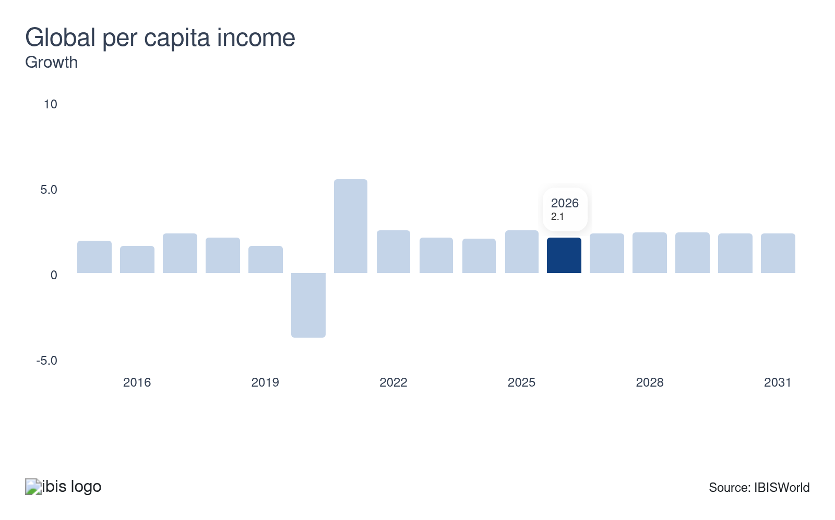
Cars and light trucks are expensive, discretionary purchases, so changes in disposable income influence demand for motor vehicles. As disposable income levels trend higher, consumers are more apt to purchase big-ticket items, specifically automobiles. Climbing global per capita disposable income represents a potential opportunity for global car and automobile manufacturers.
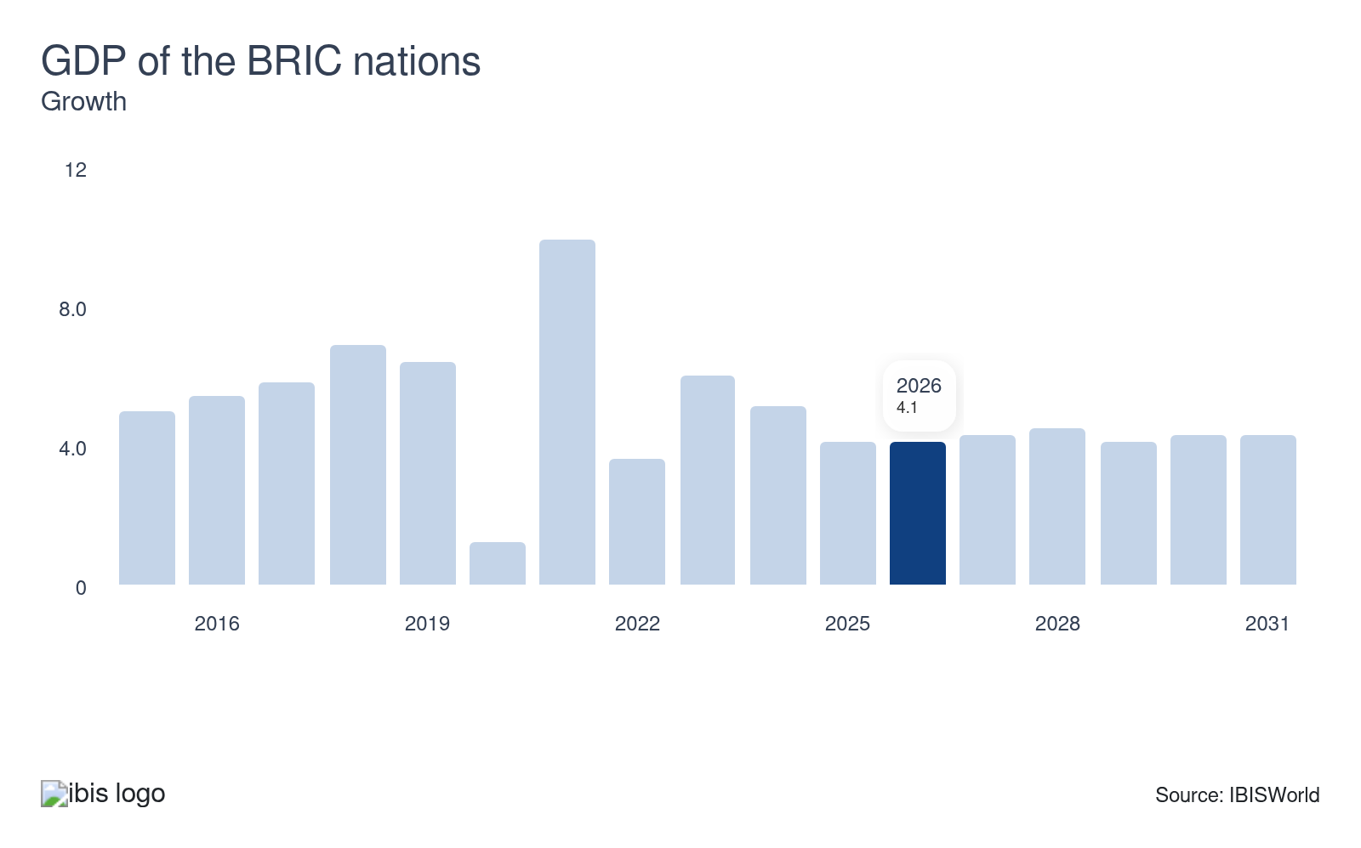
Brazil, Russia, India and China, also known as the BRIC nations, represent emerging economies with rapidly expanding industrial capacities. BRICS and BRICS+ nations have represented an increasing share of both car production and car sales, encouraging greater interest in these regions. Rising GDP supports consumer demand, particularly from these nations' growing middle class that can afford motor vehicles.
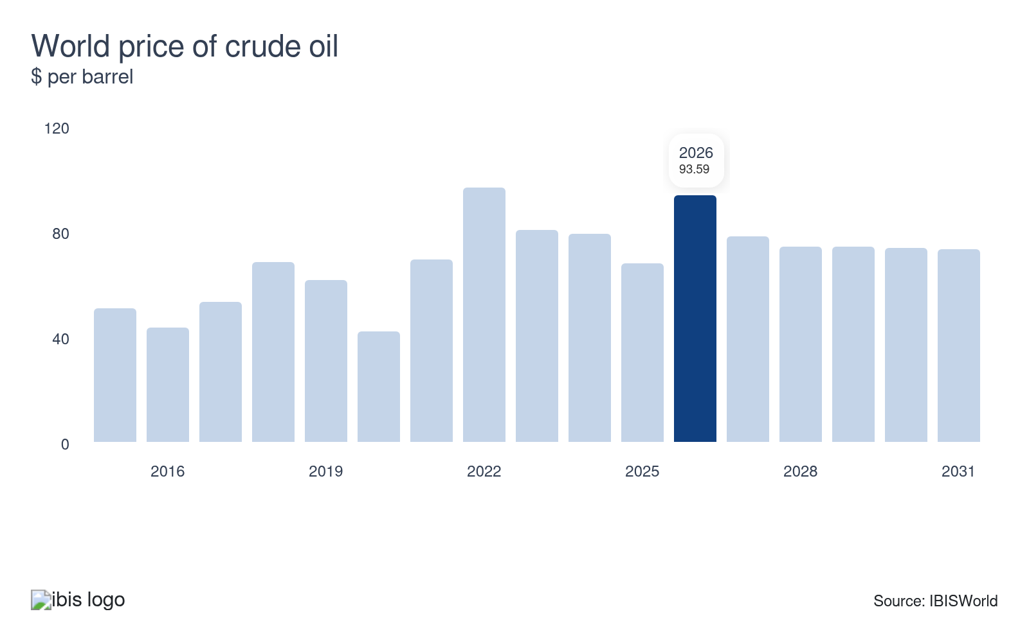
High gas prices often negatively impact a consumer's decision to purchase a new vehicle, as it costs more to operate. Even so, rising gas prices can bode well for manufacturers of hybrid and electric vehicles. Volatile crude oil prices pose a threat to global car and automobile manufacturers.
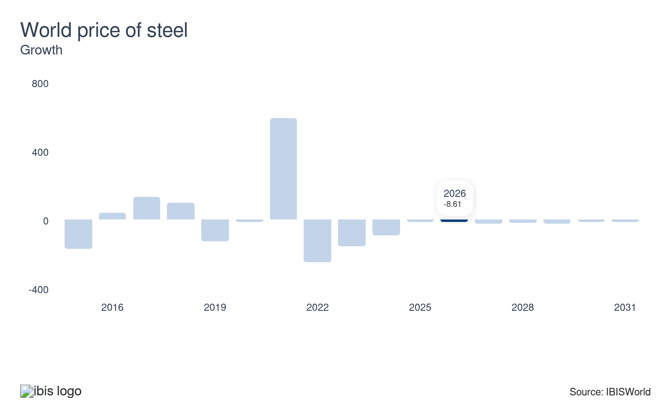
Steel is one of the many major inputs in manufacturing motor vehicles. While automakers pass rising costs onto consumers, high steel prices often constrain profit and encourage companies to switch to alternative materials, like aluminum. For instance, higher steel prices have led to bloated car prices globally, cutting into demand from consumers.

Regulation & Policy

What regulations impact the industry?

Harmonization initiatives
Global car and automobile manufacturers must comply with government regulations regarding safety, fuel economy, emissions and pollution control. Standards vary between regions, countries and locally, but global standards are starting to emerge alongside an increasingly global automotive supply chain. Gaps between emission standards are closing, with harmonization initiatives becoming a common theme of regulatory discussions. Regulations are becoming more stringent as governments and individuals grow concerned with environmental issues.

Global Auto Regulations
The UN World Forum for the Harmonization of Vehicle Regulations (WP.29) enables governments to agree on common environmental and safety requirements for motor vehicles. Companies must meet minimum standards regarding crash safety, lighting and signaling, braking and steering, tires and general vehicle safety alongside the aforementioned emissions standards.

Standards in the United States
In the United States, federal law requires that manufacturers recall vehicles if they find a defect that poses an unreasonable safety risk. The government compiles consumer complaints and will order a manufacturer to recall vehicles if warranted. The federal agency that enforces vehicle safety regulations is the National Highway Traffic Safety Administration (NHTSA). The US Environmental Protection Agency supervises all US emissions standards that directly impact Canadian and Mexican emissions standards, facilitating an almost complete harmonization of standards between these nations since automotive production in North America is centralized among the trilateral trade patterns of these three countries.

European Union Standards
The European Union has set similar emissions and consumer standards objectives, with analogous checks and balances to restore consumer confidence during corporate malfeasance and ensure public safety. The test regimes used in the EU and the US are different, which affects the stringency in practice of emissions standards. The EU’s use of the New European Driving Cycle has hampered the effectiveness of emissions standards. Notably, German manufacturer Volkswagen fell into an emissions scandal, violating the Clean Air Act in the United States and several other environmental standards.

Asian-Pacific Standards
Japan's central government and the local government in the Greater Tokyo region have implemented measures to address air quality problems caused by motor vehicles. Per national legislation aimed at curbing nitrogen oxide and other emissions in major metropolitan areas, the issuance of inspection-compliance certification is prohibited for vehicles that fail to meet the legal standards at inspection time. In addition, the Tokyo metropolitan and surrounding municipal prefectural governments have introduced regulations to reduce emissions from diesel vehicles. Similarly, China enacted its first engine emissions controls on automobiles in 2000. The social backlash to excessive smog levels has risen as the middle class has grown in China. In turn, the Chinese government has increased regulations on vehicle pollution in concordance with one of its primary trading partners, the European Union.

Antitrust regulation in China
Recently, the Chinese government has increased its antitrust investigation activity into foreign manufacturers. This trend is particularly relevant to part manufacturing but also influences luxury car prices. Global automakers wishing to continue operating in China with minimal barriers will reduce prices to pre-empt government investigation activity.

Assistance

What assistance is available to this industry?

Post-recession bailouts have shaped the industry's landscape
Due to the financial crisis and strife in the global automotive sector, governments upped their assistance over the first half of 2009. Assistance schemes ranged from cash rebates when purchasing cars (which doesn't impact manufacturers directly but boosts consumer demand) to funds injected into car companies to keep them afloat. The French government bailed out Peugeot SA and Groupe Renault in early 2009, saving thousands of jobs. The US government bailed out Fiat Chrysler Automobiles NV, now recognized as Stellantis NV, and the General Motors Company. Ultimately, the most salient form of industry assistance occurred during the financial crisis. While this is not relevant to the current period, it exemplifies the extremes governments may go to protect automotive industries.

Tariffs
Protectionist trade policies are the primary means of assistance for most manufacturers but also inhibit global growth. Governments have mostly lowered tariffs on imported cars, though some relatively high rates still exist, most notably in China. Vehicle manufacturers have increased production in developing countries, including Mexico and Brazil, to lower transportation costs and meet demand from emerging markets (and to avoid existing trade and investment restrictions). Mexico is an attractive location for automakers because of its low labor costs and proximity to the US border.

Trade agreements
The United States-Mexico-Canada Agreement (USMCA) limits tariffs between its three participating countries. The agreement's labor provisions have shifted trade in favor of the United States. Also, the 11 Pacific Rim countries benefit from the Comprehensive and Progressive Agreement for Trans-Pacific Partnership (CPATPP). This agreement includes key nations, like China, Mexico and Japan, but excludes the United States. Tariff removal will increase trade value globally; however, some countries have faced greater import penetration and weaker demand globally. These agreements will bolster member states' market share at the expense of non-member states in Europe and Asia.

Subsidies and grants for research and development
Other significant forms of assistance include subsidies, tax exemptions and government funding for research and development (R&D) initiatives. In the United States, the Department of Energy (DOE) continuously invests in science and research projects for alternative energy sources, which could cut the United States' dependence on oil and offer a cleaner energy source. In the developing world, assistance is increasing faster than in developed markets. For example, the Indian government will provide tax and profit repatriation incentives to attract further investment from multinational vehicle manufacturers. The Indian government recognizes the need to develop road infrastructure and improve labor laws. Likewise, Thailand grants a wide array of incentives, including a low tax of 3.0%. Incentives confer on the investors an eight-year tax holiday, duty-free machinery, visa and work permit support and land ownership rights. The country also gives maximum incentives to activities that support the automotive sector, including R&D, human resource development and design activities.

State-run partnerships
China, the world's largest market for cars and automobiles, is a popular destination for partnerships with global automakers. China is particularly important since its largest manufacturers, including player SAIC Motor, are state-run enterprises representing the most significant form of industry assistance worldwide.

New tariff proposals
While numerous tariffs exist in most major economies, the United States tariff proposals represent a major shake-up from the existing trade landscape. Potential for 25.0% tariffs would stifle automotive trade in North America, potentially causing a major dip in trade volumes as America is one of the larger trading partners. Additionally, the US and EU have various tariffs Chinese electric vehicles; on the other hand, Chinese protectionist policies have pushed out brands like Volkswagen, Honda and Toyota from their formerly dominant positions in China. Europe also has considerable tariffs on Tesla, predating US tariffs from 2025.

Trade associations
Outside government intervention, car manufacturers rely on numerous organizations representing their interests, including the USMCA, the Automobile Manufacturers Association and the Alliance of Automobile Manufacturers. Meanwhile, multiple US-based organizations offer resources for manufacturers since most automakers have operations across North America. These organizations provide statistics, production figures, enterprise and educational resources, licensing assistance, supply chain development and networking events. Most smaller companies and contract manufacturers rely on these associations to enter a competitive market.

Trade events and the OICA
The international auto show, held in various cities worldwide, alongside other smaller trade events, are crucial interfaces for new and niche manufacturers of automobiles to reach their desired consumer base. The most important private organization for industry advocacy is the International Organization of Motor Vehicle Manufacturers (OICA). The OICA provides a country-by-country statistical compendium of automobile production and sales, including passenger and commercial vehicles, outlining emissions standards and worldwide regulatory harmonization initiatives.

9. Financial Benchmarks
https://my.ibisworld.com/gl/en/industry/C2531-GL/financial-benchmarks
Profit Margin  7.6 %  ↑ Higher than sector | Average Wage  $50,422  ↑ Higher than sector | Largest Cost  Purchases  70.7% of Revenue

Key Takeaways
- Purchases dominate an automaker's expenses. Companies have battled supply chain shortages and volatile input prices following the pandemic, leading to long lead times and major car shortages.
- Companies have poured capital into research, development and skilled labor. Automakers have scrambled to produce hybrid, electric and self-driving vehicles. Automakers have also increasingly invested in AI, robotics and other computer-aided systems to cut wage expenses.

Cost Structure
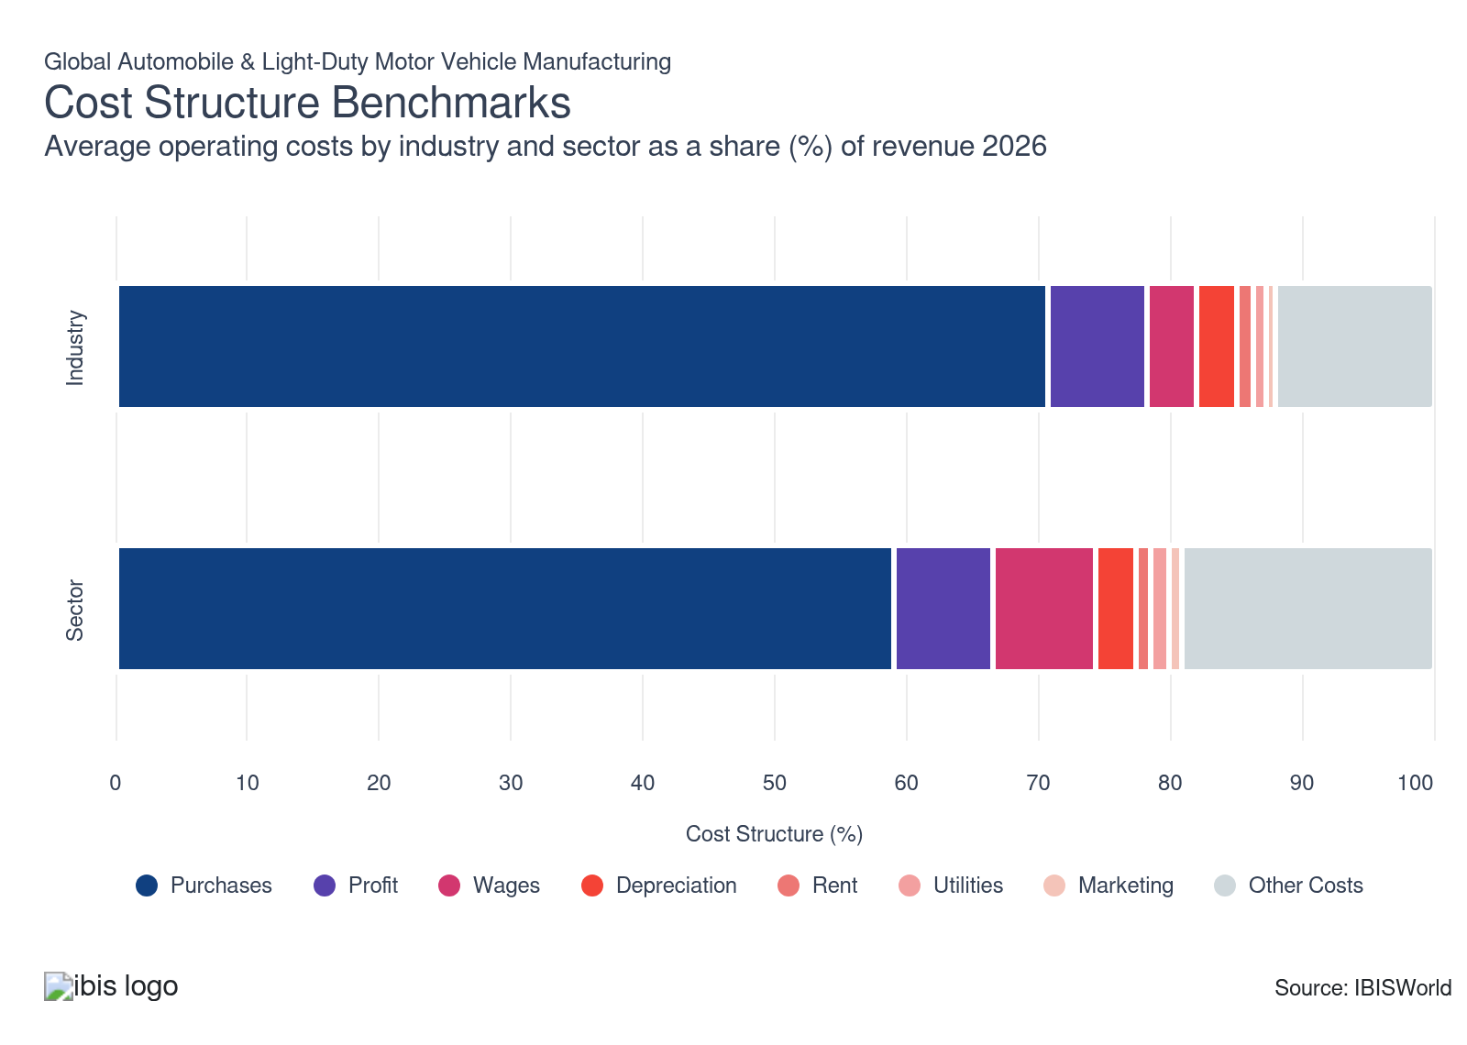
Chart displays current year only in the PDF version of this report. You can view and download chart for all other years associated with this industry on my.ibisworld.com.

What trends impact industry costs?

Major supply chain disruptions have caused changes to purchasing practices
- Purchases are the largest cost for automakers. Metals, like aluminum and steel, represent the largest input for manufacturers. Companies have increasingly shifted to aluminum to produce lighter, more fuel-efficient bodies. Steel prices also rose more than 110.0% during the pandemic, encouraging automakers to substitute with aluminum. Companies also purchase a wide range of semifinished inputs, like semiconductors, auto parts, plastics, forged goods and other miscellaneous parts.
- Vertical integration gives companies key cost advantages with auto parts, but most companies still rely on dedicated contracts and partnerships with innovative manufacturers, especially in the auto electronics space. Regardless, automakers hold notable pricing power over parts suppliers, given the industry's high concentration.
- Semiconductor shortages also led to elevated purchase costs. Automakers use semiconductors for most electronic systems, like radios, GPS, entertainment systems and driver assistance. These products are also essential in the development of advanced driving systems and electrification. These shortages led to skyrocketing car prices, longer lead times and delayed innovation timetables in recent years.
- After the shortage, many automakers have scrapped just-in-time semiconductors, preferring the stability that constant orders can provide. Severe shortages have also forced automakers to reevaluate relationships with key suppliers; many automakers are developing closer relationships with the rest of the manufacturing and technology sector to create more advanced chips, parts and components for vehicles. Electric vehicle manufacturers often have higher costs, requiring more rare earth metals and expensive battery inputs.
- Trade policies have also shaped acquisition costs. Tariffs in the United States have raised the costs of many key inputs, while restrictions on China, in both North America and Europe, have caused companies to look elsewhere for supply chains. Many companies have prioritized nearshoring, leading to increased production in lower cost regions, like Mexico, Eastern Europe and Southeast Asia.

Automakers battle cyclical profit
- Automakers largely rely on strong economic conditions to generate new car sales. The pandemic, supply chain disruptions and high interest rates have represented severe exogenous shocks to global automobile manufacturers. Improving conditions have equally spurred discretionary spending, causing many consumers in developed economies to trade up to newer, more luxurious models.
- Similarly, a waning Eurozone economy has diminished European sales for most major automakers. Favorable interest rates and corporate tax structures before the pandemic weren't enough to entice automakers to continue pursuing production there. Also, supply shortages ate into profit, forcing purchase costs to skyrocket. Even so, profit has recovered as consumers expressed pent-up demand for travel after the pandemic.
- Growth in the global middle class has also been a driving force in automaker profit. Consumers often view cars as a status symbol and are willing to spend more on luxury when incomes permit. For instance, Continental AG reported that 54.0% of younger drivers in Germany (up to the age of 34) see cars as a status symbol. This factor is doubly true in post-Socialist Eastern European societies where car ownership has skyrocketed, especially among younger generations, providing new outlets for automakers.
- Companies have also struggled to generate positive returns on electric vehicles, with Ford, GM and Stellantis reporting significant loses in EV production. However, GM has reversed this trend, displaying strong EV growth in the second-half of 2024. Conversely, Japanese automakers, like Honda and Toyota, have reported robust returns on hybrid vehicles Companies may increasingly prioritize hybrid vehicles as an intermediate goal to carbon-neutral production to salvage profit.
- On the other hand, South Korean and Chinese manufacturers, namely Hyundai, Kia, BYD and Geely, alongside the United States' Tesla, have reported mounting returns on many EV models, signaling the potential for robust EV demand and profitability.
- Profit also largely faltered in 2025, with higher-than-expected wage, input and other costs pressuring bottom lines. Some companies reported absorbing additional costs, compressing profit despite continued revenue expansion. Long-term cost absorption may damage the industry's profitability.

Automakers attempt to balance union pressure, R&D and automation
- To reduce overall costs and bolster profitability, many automakers have shifted manufacturing plants to low-cost countries, like China and Mexico, to take advantage of more affordable labor costs. The inclusion of low-cost regions, like China, Mexico or India, has driven down wage costs, despite significantly higher labor expenses in the rest of North America and the European Union.
- Many automakers have also invested heavily in hybrid, electric and autonomous vehicles, requiring skilled engineers to design and test new products. Some manufacturers have also announced layoffs and plant closures, consolidating operations around the most profitable facilities.
- Despite this trend, companies hire workers to operate complex machinery, provide quality assurance and work front-end positions. Many automakers are also restructuring labor agreements with unions. These include negotiations that impact deferred and current pensions and healthcare costs. Recent labor strikes in the United States, Canada and Germany through the UAW, Unifor and IG Metall have led to higher costs.

Electrification and vehicle automation are core R&D targets for automakers
- Research and development is crucial in the automotive sector, especially as companies face mounting regulatory pressures, changing consumer preferences and threats from the growing Chinese auto manufacturing sector. While automakers have increasingly spent on electrification, meeting emissions standards and vehicle automation, yearly R&D outlays also include constant safety testing, design improvements and aesthetic changes. Companies attempt to release differentiated models each year, encouraging consumers to trade up to the latest model.
- Many companies have partnered with various technology companies, research institutions, parts manufacturers and other automakers to advance electrification, emissions and safety goals. For instance, BMW and Toyota have partnered to develop fuel cell vehicles while GM and LG Energy Solutions have partnered to develop less expensive, safer, lighter and longer-lasting vehicle batteries.
- In general, legacy automakers have struggled to gain ground in EV markets, with Tesla having a dominant first-mover advantage while BYD, NIO, Geely and other Chinese competitors have rapidly gained ground in global markets. Companies prioritizing hybrid vehicles, specifically Korean and Japanese manufacturers, have generally found greater success both domestically and in foreign markets, given limited EV adoption rates, though strict zero-emission sales goals have necessitated aggressive research, development and design spending.

Automamkers have increasingly relied on robotics
- According to the IFR, the global manufacturing sector installed 553,052 industrial robot installations in factories around the world in 2023 (latest data available). Approximately 25.0% of all robotics installations were in the automotive sector. Of this, more than 73.0% of robots were installed in Asia, with China accounting for more than double the next fourteen countries. Japan, the United States, South Korea and Germany represent the next four highest installations.
- Overall, depreciation costs have remained relatively steady over the past two decades. In general, depreciation expenses are slightly lower than the overall manufacturing sector. Automakers must balance new cost-cutting technology with skilled labor to keep products competitive.

Automakers primarily own facilities and equipment
- Global automakers generally don't rent production or assembly facilities, instead opting to own the land and buildings. This strategy is common in the manufacturing sector. Automakers must maintain massive economies of scale to produce the output necessary to remain profitable and sate global demand.
- However, some companies may rent warehouses to store parts and other inputs before processing or cars before shipping to wholesalers, dealers and consumers. This strategy helps companies avoid vacant facilities and idling production, cutting costs and reducing risk.

Automakers strive for carbon neutrality
- Utility costs are relatively low for automakers, accounting for only 1.0% of total expenditure. These costs are generally lower in the United States and Canada than in China, accounting for just 0.2% of revenue in the US compared with 1.5% in China.
- Many automakers in developed nations have pledged to reach carbon neutrality, promoting clean energy consumption, proper waste disposal and supply chain circularity. In general, environmental restrictions are tighter in North America and the EU, forcing companies to be more efficient.
- Overall, utility expenses make up a rather small portion of total expenditure. Automakers don't have an especially energy-intensive processes, falling in line with the majority of the manufacturing sector.

Savvy marketing can give automakers an edge
- The largest manufacturers use extensive advertising and promotions to gain customer attention and improve brand recognition. Many manufacturers will attempt to associate their brand with specific qualities. For example, many automakers will emphasize their car's fuel efficiency, safety features or luxurious qualities, potentially appealing to families or high-spenders respectively. Branding is crucial to securing market share and maintaining a company's competitive edge in a highly saturated market.
- Automakers have increasingly prioritized online tactics, often involving social media and search engine optimization, to attract younger buyers and develop long-standing relationships with these demographics. Even so, television commercials remain a mainstay for automakers, showcasing new model year designs, awards and other innovations.
- However, poor marketing can backfire, as seen with the heavy uncertainty following Jaguar's rebranding. In general, marketing tactics are an afterthought for automakers compared to the industry's sheer expenditure on wages, purchases and R&D. Instead, dealers often handle more directed advertising.
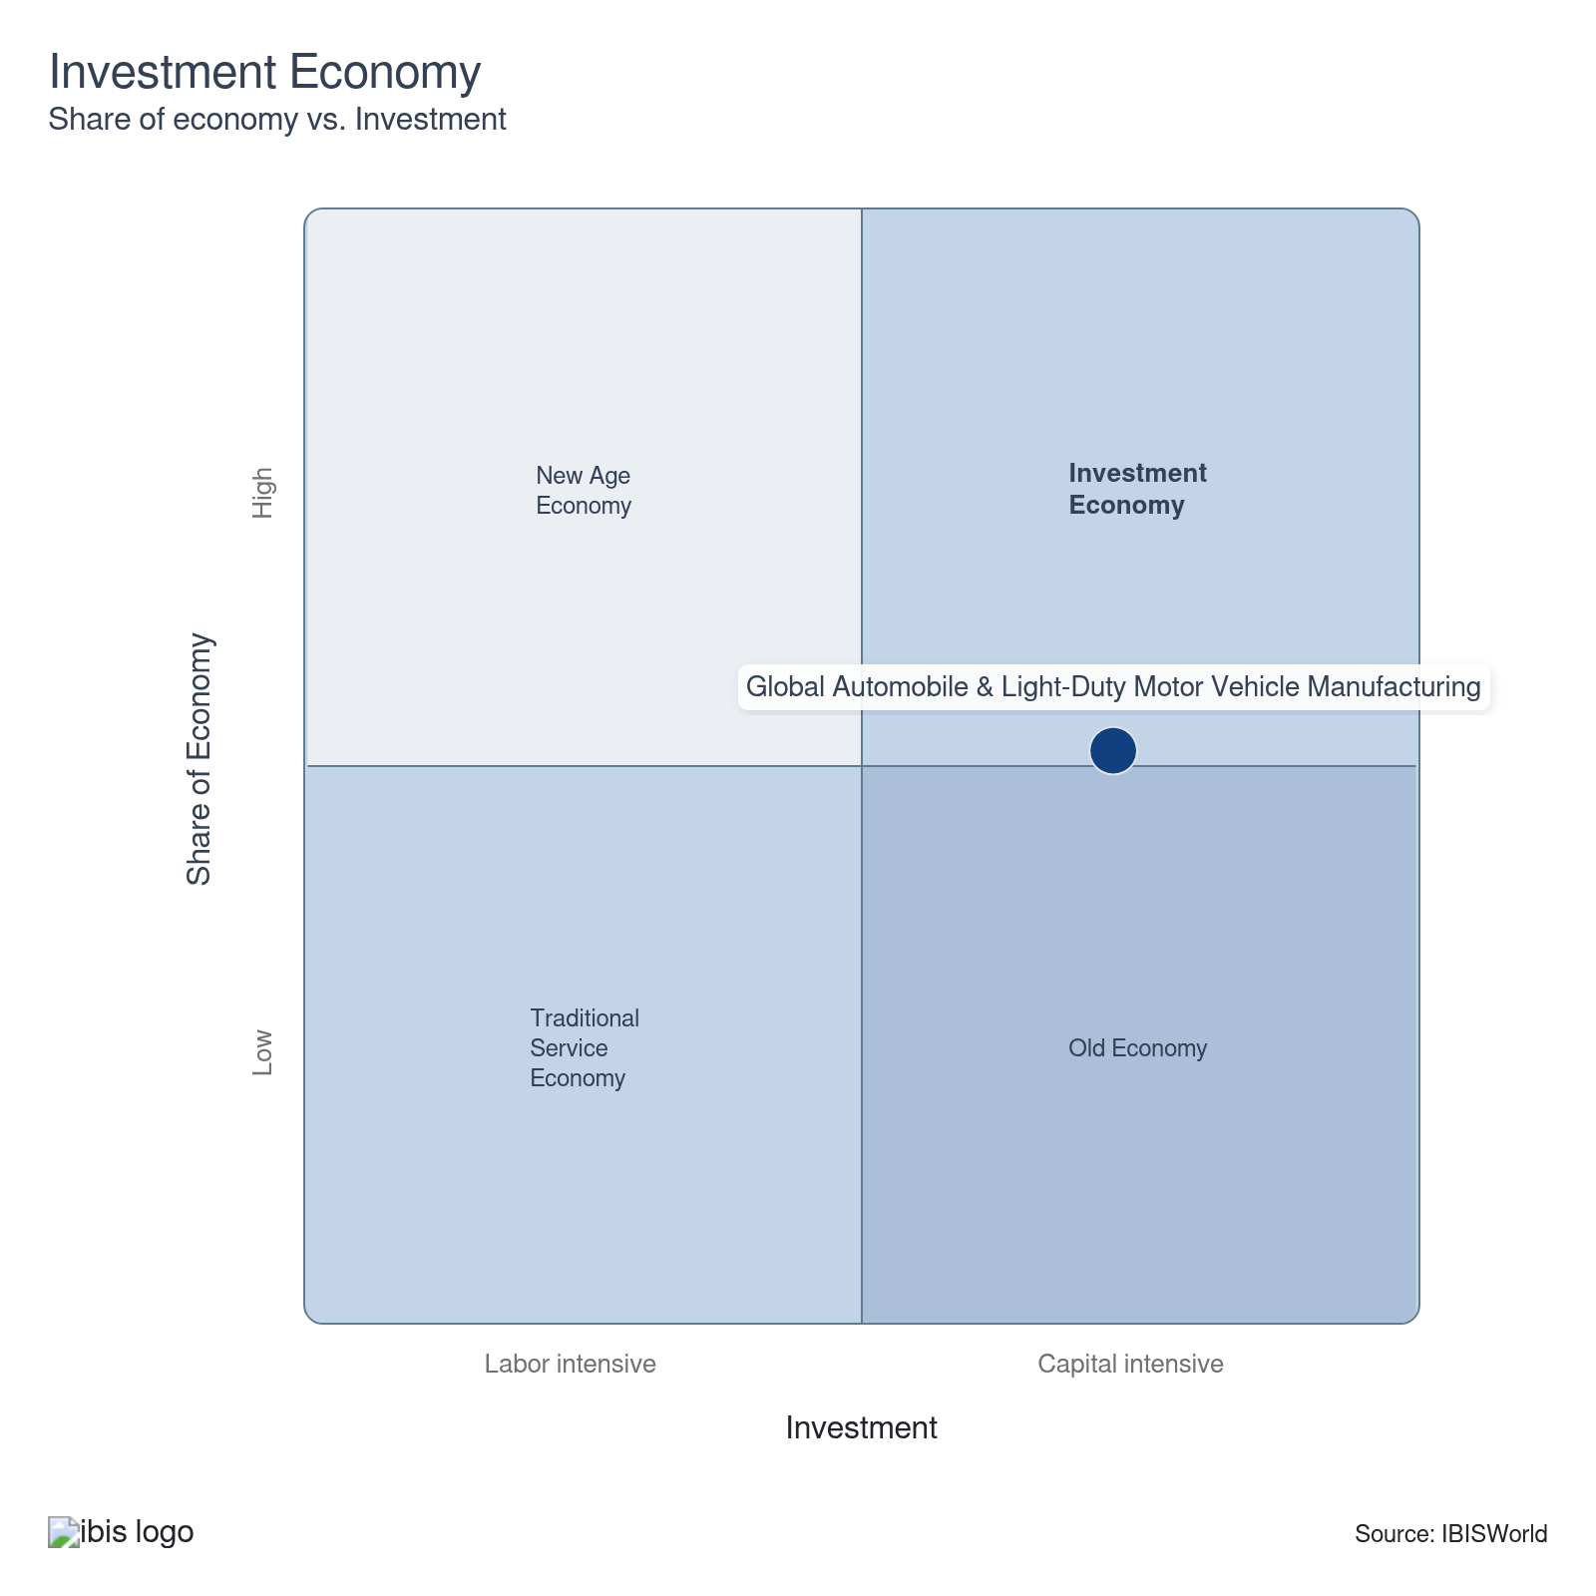

Key Ratios
Year | Revenue per Employee  ($) | Revenue per Enterprise  ($ Million) | Employees per Estab.  (Units) | Employees per Enterprise  (Units) | Average Wage  ($) | Wages/ Revenue  (%) | Estab. per Enterprise  (Units) | IVA/ Revenue  (%) | Imports/ Demand  (%) | Exports/ Revenue  (%)
2005 | 1,968,006 | 1411.6 | 434.3 | 717.3 | 99,100 | 5.0 | 1.7 | 5.9 | 39.5 | 39.5
2006 | 1,793,387 | 1526.4 | 483.6 | 851.1 | 86,490 | 4.8 | 1.8 | 5.7 | 39.1 | 39.1
2007 | 1,969,848 | 1717.3 | 473.6 | 871.8 | 85,716 | 4.4 | 1.8 | 8.0 | 38.6 | 38.6
2008 | 1,655,431 | 1660.1 | 491.3 | 1002.8 | 66,498 | 4.0 | 2.0 | 4.8 | 43.6 | 43.6
2009 | 1,150,405 | 1897.5 | 731.2 | 1649.4 | 51,894 | 4.5 | 2.3 | 10.2 | 55.7 | 55.7
2010 | 1,435,932 | 2546.1 | 795.9 | 1773.1 | 55,189 | 3.8 | 2.2 | 16.3 | 29.8 | 29.8
2011 | 1,426,531 | 2997.2 | 953.6 | 2101.0 | 52,720 | 3.7 | 2.2 | 18.0 | 33.2 | 33.2
2012 | 1,445,346 | 3290.0 | 1048.3 | 2276.2 | 55,209 | 3.8 | 2.2 | 15.8 | 34.9 | 34.9
2013 | 1,457,391 | 3426.8 | 1029.7 | 2351.3 | 50,189 | 3.4 | 2.3 | 16.5 | 32.6 | 32.6
2014 | 1,513,383 | 3779.1 | 1051.4 | 2497.1 | 49,827 | 3.3 | 2.4 | 17.0 | 31.5 | 31.5
2015 | 1,531,816 | 3805.8 | 1048.1 | 2484.5 | 51,343 | 3.4 | 2.4 | 18.0 | 32.7 | 32.7
2016 | 1,511,242 | 3889.3 | 1136.7 | 2573.6 | 51,110 | 3.4 | 2.3 | 18.5 | 31.3 | 31.3
2017 | 1,354,115 | 3737.1 | 1249.6 | 2759.8 | 50,947 | 3.8 | 2.2 | 18.0 | 31.7 | 31.7
2018 | 1,319,260 | 3753.2 | 1322.2 | 2845.0 | 50,766 | 3.8 | 2.2 | 14.6 | 31.7 | 31.7
2019 | 1,263,174 | 3679.7 | 1384.0 | 2913.1 | 49,592 | 3.9 | 2.1 | 13.4 | 32.1 | 32.1
2020 | 1,186,875 | 3552.6 | 1391.7 | 2993.2 | 47,836 | 4.0 | 2.2 | 12.7 | 36.0 | 36.0
2021 | 1,183,559 | 3465.2 | 1392.2 | 2927.8 | 47,471 | 4.0 | 2.1 | 13.3 | 28.4 | 28.4
2022 | 1,233,156 | 3144.7 | 1246.7 | 2550.1 | 47,321 | 3.8 | 2.0 | 15.0 | 30.9 | 30.9
2023 | 1,320,209 | 3233.5 | 1207.6 | 2449.2 | 50,091 | 3.8 | 2.0 | 14.7 | 32.0 | 32.0
2024 | 1,335,073 | 3199.2 | 1181.0 | 2396.3 | 50,210 | 3.8 | 2.0 | 13.8 | 40.6 | 40.6
2025 | 1,348,507 | 3250.5 | 1188.8 | 2410.5 | 50,312 | 3.7 | 2.0 | 11.4 | 40.7 | 40.7
2026 | 1,363,432 | 3303.1 | 1193.3 | 2422.6 | 50,422 | 3.7 | 2.0 | 14.4 | 41.1 | 41.1
2027 | 1,381,664 | 3362.7 | 1198.8 | 2433.8 | 50,557 | 3.7 | 2.0 | 14.7 | 41.3 | 41.3
2028 | 1,396,351 | 3402.4 | 1200.3 | 2436.6 | 50,664 | 3.6 | 2.0 | 14.8 | 41.3 | 41.3
2029 | 1,411,833 | 3447.0 | 1202.8 | 2441.5 | 50,776 | 3.6 | 2.0 | 14.9 | 41.3 | 41.3
2030 | 1,424,617 | 3505.2 | 1210.7 | 2460.4 | 50,868 | 3.6 | 2.0 | 14.9 | 41.3 | 41.3
2031 | 1,434,115 | 3551.6 | 1218.0 | 2476.5 | 50,936 | 3.6 | 2.0 | 14.8 | 41.2 | 41.2
2032 | 1,439,981 | 3589.7 | 1224.0 | 2492.9 | 50,978 | 3.5 | 2.0 | 14.8 | 41.2 | 41.2
*Figures are inflation adjusted to 2026
*Figures are inflation adjusted to 2026

10. Key Statistics
https://my.ibisworld.com/gl/en/industry/C2531-GL/key-statistics

Industry Data

Values
Year | Revenue  ($ Million) | IVA  ($ Million) | Estab.  (Units) | Enterprises  (Units) | Employment  (Units) | Exports  ($ Million) | Imports  ($ Million) | Wages  ($ Million)
2005 | 1,860,491.5 | 110,307.0 | 2,177 | 1,318 | 945,369 | 734,131.8 | 734,131.8 | 93,686.5
2006 | 1,932,465.5 | 110,084.5 | 2,228 | 1,266 | 1,077,551 | 755,294.7 | 755,294.7 | 93,197.0
2007 | 2,095,162.2 | 168,026.9 | 2,246 | 1,220 | 1,063,616 | 807,974.0 | 807,974.0 | 91,168.9
2008 | 2,126,613.4 | 102,558.0 | 2,615 | 1,281 | 1,284,628 | 927,916.0 | 927,916.0 | 85,424.9
2009 | 1,684,971.3 | 172,322.0 | 2,003 | 888 | 1,464,676 | 937,816.3 | 937,816.3 | 76,008.5
2010 | 2,156,546.8 | 351,533.7 | 1,887 | 847 | 1,501,845 | 642,282.3 | 642,282.3 | 82,884.7
2011 | 2,388,757.5 | 430,278.9 | 1,756 | 797 | 1,674,522 | 793,449.4 | 793,449.4 | 88,280.2
2012 | 2,553,014.7 | 404,319.7 | 1,685 | 776 | 1,766,369 | 889,761.1 | 889,761.1 | 97,518.9
2013 | 2,744,853.5 | 452,621.4 | 1,829 | 801 | 1,883,402 | 895,877.6 | 895,877.6 | 94,525.2
2014 | 2,891,030.0 | 490,406.5 | 1,817 | 765 | 1,910,310 | 911,013.5 | 911,013.5 | 95,185.8
2015 | 2,896,233.4 | 521,725.6 | 1,804 | 761 | 1,890,719 | 946,714.5 | 946,714.5 | 97,075.1
2016 | 2,901,447.2 | 535,446.9 | 1,689 | 746 | 1,919,909 | 907,194.5 | 907,194.5 | 98,125.6
2017 | 2,903,737.8 | 521,413.9 | 1,716 | 777 | 2,144,381 | 919,638.1 | 919,638.1 | 109,249.3
2018 | 3,043,870.4 | 444,226.0 | 1,745 | 811 | 2,307,256 | 964,648.9 | 964,648.9 | 117,130.5
2019 | 3,054,182.4 | 409,410.3 | 1,747 | 830 | 2,417,863 | 980,176.7 | 980,176.7 | 119,907.6
2020 | 2,685,773.0 | 340,954.6 | 1,626 | 756 | 2,262,894 | 967,505.3 | 967,505.3 | 108,246.8
2021 | 2,727,094.9 | 361,470.0 | 1,655 | 787 | 2,304,147 | 773,658.1 | 773,658.1 | 109,379.2
2022 | 2,622,675.6 | 392,093.6 | 1,706 | 834 | 2,126,800 | 809,643.8 | 809,643.8 | 100,642.6
2023 | 2,648,198.7 | 389,325.5 | 1,661 | 819 | 2,005,894 | 846,343.7 | 846,343.7 | 100,476.5
2024 | 2,533,764.1 | 349,836.7 | 1,607 | 792 | 1,897,847 | 1,029,596.0 | 1,029,596.0 | 95,291.8
2025 | 2,580,930.0 | 294,685.9 | 1,610 | 794 | 1,913,917 | 1,049,528.0 | 1,049,528.0 | 96,292.6
2026 | 2,619,366.0 | 377,296.3 | 1,610 | 793 | 1,921,157 | 1,075,818.0 | 1,075,818.0 | 96,868.2
2027 | 2,666,648.3 | 390,715.7 | 1,610 | 793 | 1,930,027 | 1,100,492.7 | 1,100,492.7 | 97,575.7
2028 | 2,718,522.0 | 402,415.3 | 1,622 | 799 | 1,946,876 | 1,122,600.5 | 1,122,600.5 | 98,636.8
2029 | 2,771,411.2 | 412,337.9 | 1,632 | 804 | 1,962,988 | 1,145,155.2 | 1,145,155.2 | 99,673.6
2030 | 2,825,171.5 | 420,523.1 | 1,638 | 806 | 1,983,109 | 1,168,097.9 | 1,168,097.9 | 100,877.6
2031 | 2,880,348.3 | 426,699.7 | 1,649 | 811 | 2,008,450 | 1,186,613.8 | 1,186,613.8 | 102,302.9
2032 | 2,936,397.4 | 435,714.7 | 1,666 | 818 | 2,039,192 | 1,208,756.1 | 1,208,756.1 | 103,953.8

*Figures are inflation adjusted to 2026

Annual Change
Year | Revenue  % | IVA  % | Estab.  % | Enterprises  % | Employment  % | Exports  % | Imports  % | Wages  %
2005 | N/A | N/A | N/A | N/A | N/A | N/A | N/A | N/A
2006 | 3.9 | -0.2 | 2.3 | -3.9 | 14.0 | 2.9 | 2.9 | -0.5
2007 | 8.4 | 52.6 | 0.8 | -3.6 | -1.3 | 7.0 | 7.0 | -2.2
2008 | 1.5 | -39.0 | 16.4 | 5.0 | 20.8 | 14.8 | 14.8 | -6.3
2009 | -20.8 | 68.0 | -23.4 | -30.7 | 14.0 | 1.1 | 1.1 | -11.0
2010 | 28.0 | 104.0 | -5.8 | -4.6 | 2.5 | -31.5 | -31.5 | 9.0
2011 | 10.8 | 22.4 | -6.9 | -5.9 | 11.5 | 23.5 | 23.5 | 6.5
2012 | 6.9 | -6.0 | -4.0 | -2.6 | 5.5 | 12.1 | 12.1 | 10.5
2013 | 7.5 | 11.9 | 8.5 | 3.2 | 6.6 | 0.7 | 0.7 | -3.1
2014 | 5.3 | 8.3 | -0.7 | -4.5 | 1.4 | 1.7 | 1.7 | 0.7
2015 | 0.2 | 6.4 | -0.7 | -0.5 | -1.0 | 3.9 | 3.9 | 2.0
2016 | 0.2 | 2.6 | -6.4 | -2.0 | 1.5 | -4.2 | -4.2 | 1.1
2017 | 0.1 | -2.6 | 1.6 | 4.2 | 11.7 | 1.4 | 1.4 | 11.3
2018 | 4.8 | -14.8 | 1.7 | 4.4 | 7.6 | 4.9 | 4.9 | 7.2
2019 | 0.3 | -7.8 | 0.1 | 2.3 | 4.8 | 1.6 | 1.6 | 2.4
2020 | -12.1 | -16.7 | -6.9 | -8.9 | -6.4 | -1.3 | -1.3 | -9.7
2021 | 1.5 | 6.0 | 1.8 | 4.1 | 1.8 | -20.0 | -20.0 | 1.0
2022 | -3.8 | 8.5 | 3.1 | 6.0 | -7.7 | 4.7 | 4.7 | -8.0
2023 | 1.0 | -0.7 | -2.6 | -1.8 | -5.7 | 4.5 | 4.5 | -0.2
2024 | -4.3 | -10.1 | -3.3 | -3.3 | -5.4 | 21.7 | 21.7 | -5.2
2025 | 1.9 | -15.8 | 0.2 | 0.3 | 0.8 | 1.9 | 1.9 | 1.1
2026 | 1.5 | 28.0 | 0.0 | -0.1 | 0.4 | 2.5 | 2.5 | 0.6
2027 | 1.8 | 3.6 | 0.0 | 0.0 | 0.5 | 2.3 | 2.3 | 0.7
2028 | 1.9 | 3.0 | 0.7 | 0.8 | 0.9 | 2.0 | 2.0 | 1.1
2029 | 1.9 | 2.5 | 0.6 | 0.6 | 0.8 | 2.0 | 2.0 | 1.1
2030 | 1.9 | 2.0 | 0.4 | 0.2 | 1.0 | 2.0 | 2.0 | 1.2
2031 | 2.0 | 1.5 | 0.7 | 0.6 | 1.3 | 1.6 | 1.6 | 1.4
2032 | 1.9 | 2.1 | 1.0 | 0.9 | 1.5 | 1.9 | 1.9 | 1.6

*Figures are inflation adjusted to 2026

DISCLAIMER
This product has been supplied by IBISWorld Inc. (‘IBISWorld’) solely for use by its authorized licenses strictly in accordance with their license agreements with IBISWorld. IBISWorld makes no representation to any other person with regard to the completeness or accuracy of the data or information contained herein, and it accepts no responsibility and disclaims all liability (save for liability which cannot be lawfully disclaimed) for loss or damage whatsoever suffered or incurred by any other person resulting from the use of, or reliance upon, the data or information contained herein. Copyright in this publication is owned by IBISWorld Inc. The publication is sold on the basis that the purchaser agrees not to copy the material contained within it for other than the purchasers own purposes. In the event that the purchaser uses or quotes from the material in this publication – in papers, reports, or opinions prepared for any other person – it is agreed that it will be sourced to: IBISWorld Inc.

